Pattern Suggestions (but feel free to use your own!)
Knitting
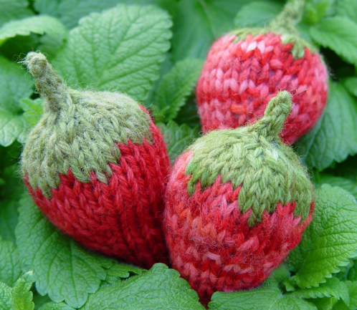
:NOT FOR COMMERCIAL USE:: PLEASE DO NOT SELL PATTERN OR FINISHED ITEMS MADE FROM THIS PATTERN::
Knit Strawberry Pattern by Pezdiva
Yarn: worsted weight - heavy, light, doesn't seem to matter. I used LB Fisherman's in the photos
Needles: I used size 6 DPN but I knit loose. Use a size that makes a nice somewhat stiff fabric
CO - Cast On
KFB - Knit into the front and back
st - stitch
k2tog - Knit to stitches together

CO 6sts on to 3 DPN - mark beginning of round, join making sure not to twist stitches
1. *KFB KI* - repeat** end of round (9st)
2. Knit
3. *KFB K2* - repeat** end of round (12st)
4. Knit
5. *KFB K3* - repeat** end of round (15st)
6. Knit
7. *KFB K4 * - repeat** end of round (18st)
8. Knit
9. *KFB K2, KFB K2*- repeat** end of round (24st)
10. Knit
11. *KFB K3, KFB K3* - repeat** end of round (30st)
12. With green yarn K1 st, with red yarn K4 st – repeat pattern until end of round
13. Knit next round using green yarn before and after every previous green stitch, continue using red yarn
14. Cut red yarn and Knit round in green
15. *K2tog K3* - repeat ** until end of round (24st)
16. k2tog – all around (12st) begin stuffing berry
17. k2tog – all around (6st)
18. k2tog – all around (3st)
19. icord stem until stem is length you like, bind off – weave in all ends.

Tip – when doing color work twist yarn colors over each other, for example when going from red to green, bring green up over red yarn. This will make a nice smooth color transition with no holes.

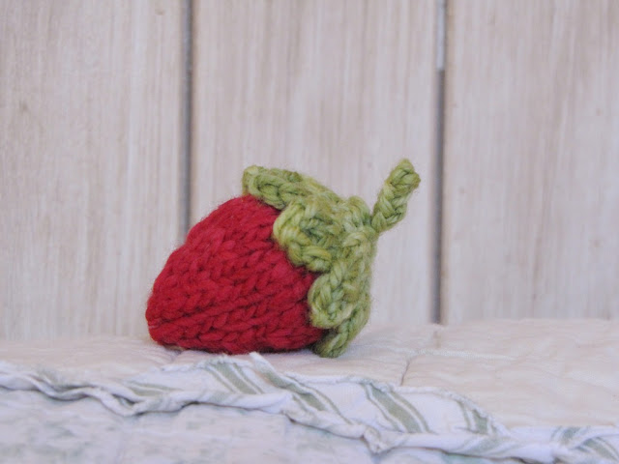
Pattern taken from Strawberry Knitting Pattern and Yarn Along - Natural Suburbia
Materials:
Red and green oddments of yarn
4mm circular needles
Merino stuffing
Sewing up needle
4mm DPNs to knit the stalk i-cord

Pattern:
Cast on 4 stitches and join for knitting in the round.
Round 1:Knit
Round 2: Kfb all stitches. (8 stitches)
Round 3: Kfb all stitches. (16 stitches)
Round 4: Knit
Round 5: (Knit 2, kfb) across the round, knit 1. (21 stitches)
Round 6: Knit
Round 7: Knit
Round 8: Knit
Round 9: (Knit 2, knit 2 together) across the round, knit 1 on the end. (16 stitches)
Round 10: Knit.
Round 11: (Knit 2, knit 2 together) across the round. (12 stitches)
Round 12: Knit
Round 13: (Knit 1, knit 2 together) across the round. (8 stitches)
Round 14: Knit
Start stuffing your strawberry now.
Round 15: (Knit 1, knit 2 together) across the round, knit 1 stitch on the end. (6 stitches)
Cut thread, thread needle and put stitches on the sewing needle, make sure you have stuffed the strawberry sufficiently, pull the stitches tight.
Finish off.
Sew in any ends.
Green Top:
Cast on 4 stitches, join for knitting in the round.
Round 1: Knit
Round 2: kfb into all stitches. (8 stitches)
Round 3: Knit
Round 4: kfb all stitches. (16 stitches)
Round 5: Knit
Round 6: (Knit 1, kfb) across the round. (24 stitches)
Round 7: Knit 3, ***turn, purl 3, turn, knit 1, knit 2 together, turn, purl 2 together, turn, put the first stitch from the left needle over onto the right needle.
Pick up 2 stitches along the left side of the knitting on the right needle.
Cast them off by knitting them across onto the right needle one by one and passing the right stitch over each knitted stitch.
Place the right needle’s stitch on the left needle and knit 2 stitches together, knit 2.***
Knit from *** to ***
Continue to knit this way until all the stitches have been knitted.
Cast off the last 2 stitches down the side of the little leaf, finish off and sew in ends.

Crochet
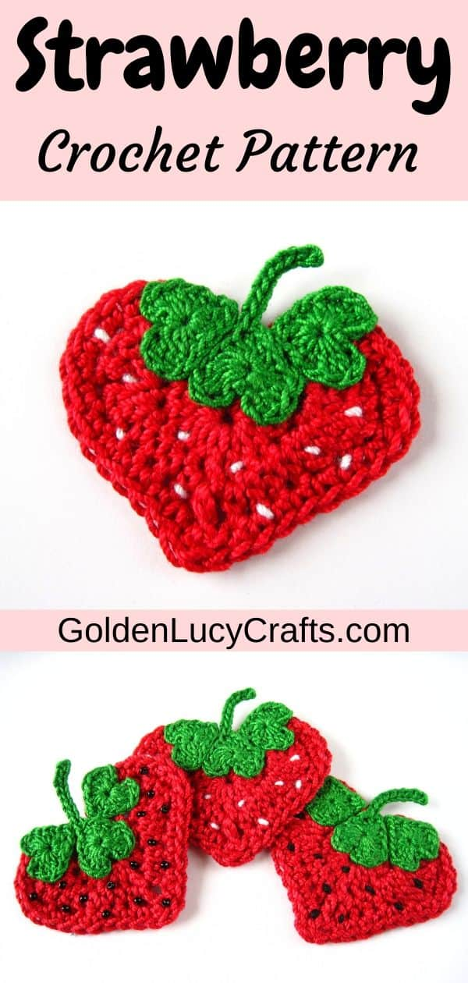

Please note: This pattern uses AMERICAN terminology

Abbreviations:
– Ch (Chs) – chain ( chains)
– DC – double crochet
– HDC – half double crochet

– Sl St – slip stitch

Finished Size:
This crochet strawberry applique is about 2-1/8” (5.5 cm).
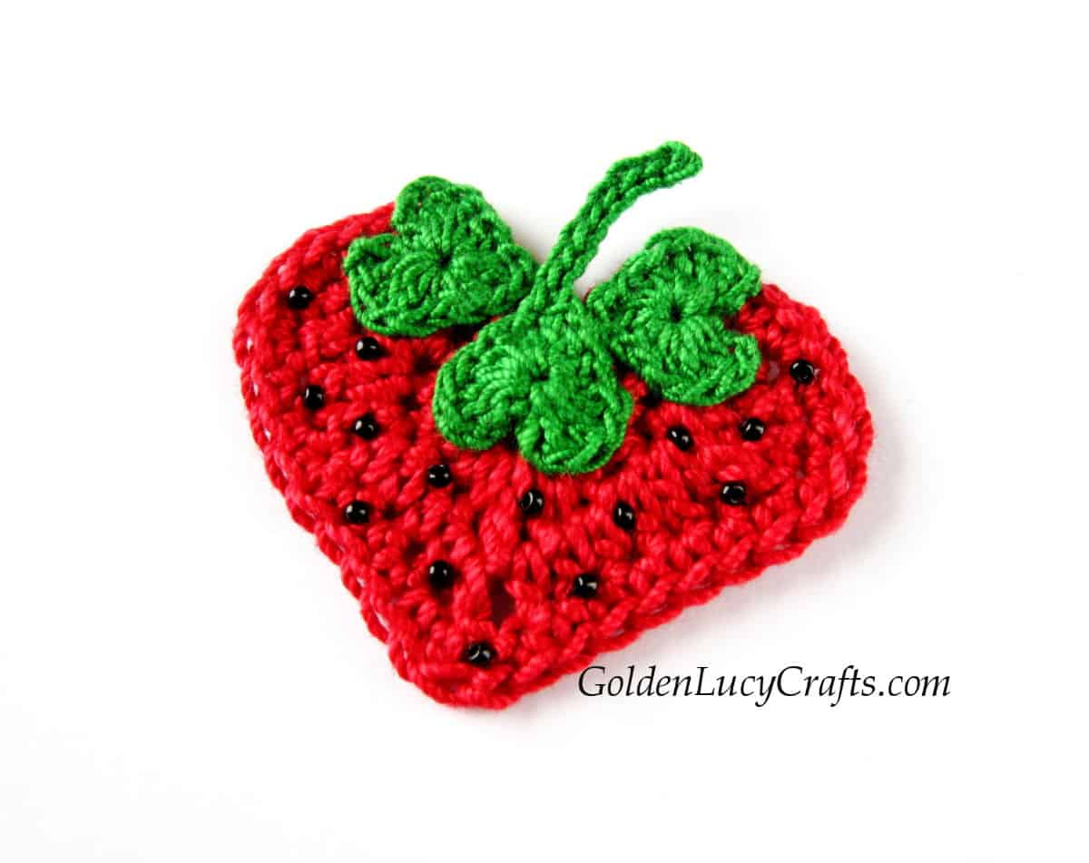

Suggested Materials:
- Aunt Lydia’s crochet cotton thread size 3, color – scarlet
- Aunt Lydia’s crochet cotton thread size 10, color – myrtle green
- crochet hook D/3 – 3.25 mm
- crochet hook size 8/1.5 mm
- cotton crochet thread size 3, or embroidery floss, color – black or white – for the seeds
- black 11/0 glass seed beads or beads of your choice – optional
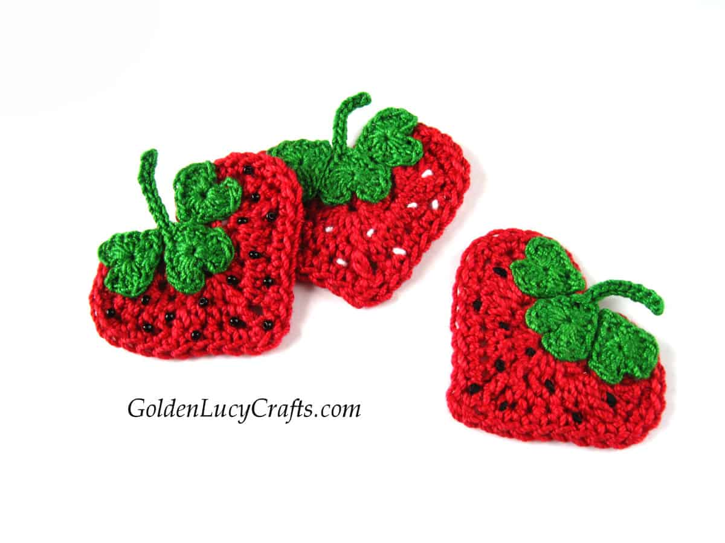

Instructions:
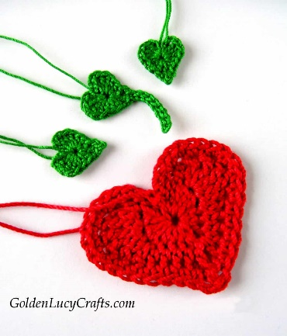

Large Heart
With red crochet cotton thread size 3 and hook D/3 – 3.25mm, Ch 4;
Rnd 1. Make all of the next stitches into the fourth Ch from hook (the first Ch made) working under both loops – 3 DC, 3 HDC, Ch 1, DC (Heart point), Ch 1, 3 HDC, 3 DC; Ch 3, Sl St in center.
Rnd 2. Ch 3, HDC + DC in first St, 3 TR in next St, 2 DC in next St, HDC in each of next 3 Sts, HDC in Ch-1 St, Ch 1, DC in next St (Heart point),
Ch 1, HDC in Ch-1 St, HDC into each of next 3 Sts, 2 DC in next St, 3 TR in next St, DC + HDC in next St, Ch 3, Sl St in center.
Rnd 3. Ch 3, SC in first St, 2 SC in each of next 4 Sts, SC in each of the next 6 Sts, SC in Ch-1 St, Ch 1, DC in next St (Heart point),
Ch 1, SC in Ch-1 St, SC in each of the next 6 Sts, 2 SC in each of next 4 Sts, SC in next St, Ch 3, Sl St in center. Fasten off.

Leafy part

Small Heart – make 2
With green crochet cotton thread size 10 and hook 8/1.5 mm, Ch 4;
Rnd 1. Make all of the next stitches into the fourth Ch from hook (the first Ch made) working under both loops – 3 DC, 3 HDC, Ch 1, DC (Heart point) , Ch 1, 3 HDC, 3 DC; Ch 3, Sl St in center. Fasten off.

Small Heart with Stem
With green crochet cotton thread size 10 and hook 8/1.5 mm, Ch 4;
Rnd 1. Make all of the next stitches into the fourth Ch from hook (the first Ch made) working under both loops – 3 DC, 3 HDC, Ch 1, DC (Heart point),
Ch 9 for the stem, Sl St into 2nd Ch from the hook and into each of next 7 Chs, Sl St into top of last DC, 3 HDC, 3 DC; Ch 3, Sl St in center. Fasten off.
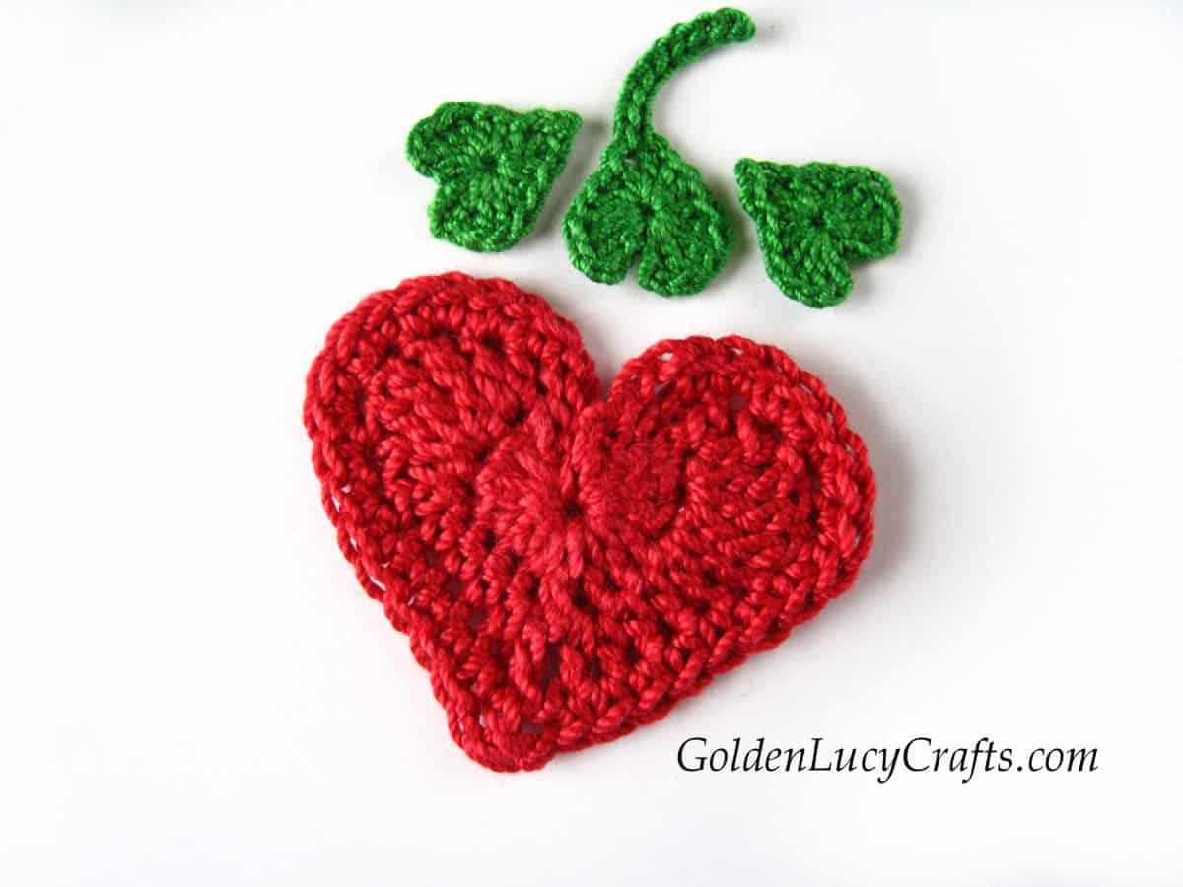

Finishing
Using my picture as a guide, sew the hearts together.
Make seeds – you can make them black or white, you can embroider them or sew on seed beads instead.

