Parish of Christ the King, Newcastle
Role Description for Children and Families Worker
Introduction
Summary
The Parish of Christ the King is seeking a Children and Families Worker who is passionate about engaging creatively to communicate God’s loving grace to the children and families of our parish. We are looking for someone with the skills to work with the ministry team to grow and develop missional work in our context. We want to work with the successful applicant to see how their passions and talents can bear fruit here, nurturing whatever gifts they will bring to the role and open to discovering how they can fit into it. Previous experience in this ministry is desirable but not essential, and the successful applicant would be working in a collaborative team that will support and stretch one another. You won’t be expected to do it all, but would be a core part of enabling a shared vision for mission to Children and Families to come to reality!
Together with a Children and Families worker we are particularly aiming to:
- reach out to families in our area, building relationships and community as well as engaging them with the story of faith;
- nurture the families who already attend our churches, enabling their faith to flourish and their children to be equipped to explore faith as they grow and mature;
- enable and equip the existing congregations to be confident in their own ministries to younger people;
- work primarily with families of primary-age children or younger, but experience or enthusiasm for work with older young people would add value to this post.
Context
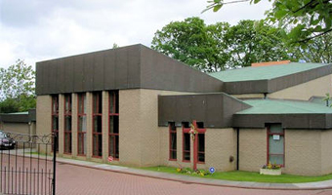
The Parish of Christ the King is a Team Parish covering suburban, outer suburban and rural areas in the north of Newcastle, with a total of population of approximately 25,000. This is an area of significant development with several new housing estates, largely attracting young families to the area. Newcastle Great Park, the largest of these, has a planned 4,000+ homes in total. Despite its size it has little in the way of community development and no permanent Christian presence – though the Fresh Expression, Church in the Park, has been active in varying forms for the last few years.
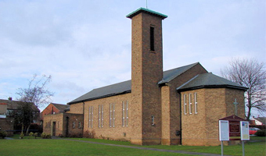
The Team Parish covering this area is made up of four churches and a Fresh Expression, with each overseen by a Team Vicar, under the Team Rector based at St Aidan’s. The focus of this post is between the churches of St Aidan’s (Brunton Park and surrounding areas), St Columba’s (Wideopen and surrounding areas) and Church in the Park (Newcastle Great Park). These churches cover the areas of most significant growth in this younger demographic.
Seaton Burn and Brunswick are more established communities with areas of some deprivation, and there is scope to explore engagement with families and their needs in these areas.
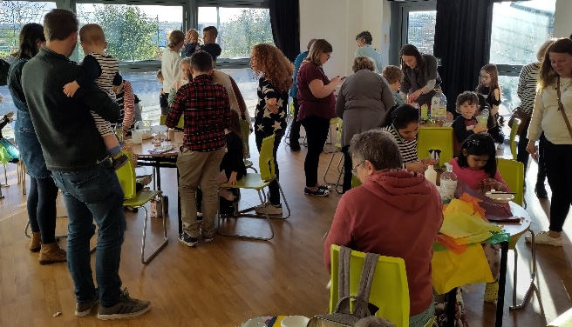
Current mission to children and families
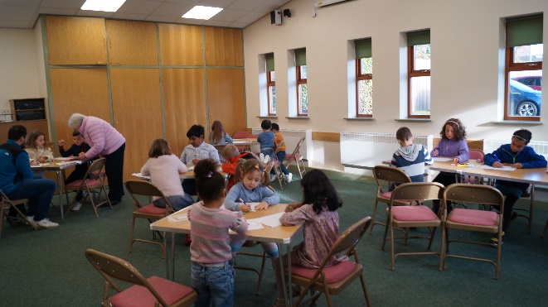
The churches in the team have a strong desire to develop our existing work with children and families. We believe that engaging with new generations is a critical imperative for the church in our modern context. In a culture that is often disengaged and uninformed when it comes to Christian faith, we hope to encourage more of our parish, and particularly children and their families, to discover a welcoming community of faith, a message of hope and grace, and the work of God’s Spirit in their own lives. We believe that enabling opportunities to discover this in contexts and formats that are welcoming and accessible to the un-churched is essential.
Our context shows clear signs of the fruit of missional work in this area. In recent times we have seen growth in attendance and engagement of children and families. Existing provision includes:
- Regular outreach events – this evolved from a Messy Church into less-regular but bigger events. They have attracted up to 50-60 children and their parents to events with craft, games, food and a Christian reflection/story.
- Parish Youth Group – weekly on a Friday evening at St Aidan’s church with an attendance of 9 regulars, aged 11-16.
- St Aidan’s Family Service – monthly on the first Sunday as our main act of worship. This is engaging particularly with Baptism families, and usually attended by 20-30 children and their families, as well as the wider congregation.
- Regular Sunday Worship – at St Aidan’s there is weekly provision of a ‘kid’s group’ with 15 regular attendees under 11. At St Columba’s older young people are active in participating in the liturgy as servers.
- Schools Work – this covers three First Schools in Great Park and Wideopen with regular assemblies as well as church visits (including Messy Church style visits), and other opportunities to engage creatively.
- Parents Discussion Group – a group encouraging parents, including those more recently attending church, to deepen their own faith and encourage their children. Recently we ran the ‘Raising Faith’ course from Care for the Family.
- Carer and Toddler Groups – affiliated to St Columba’s and St Aidan’s.

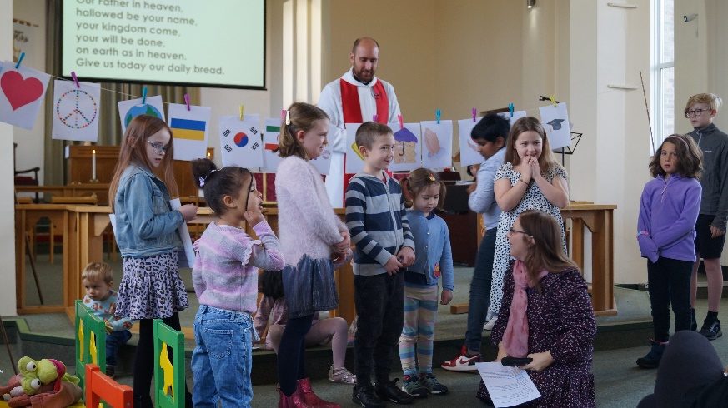
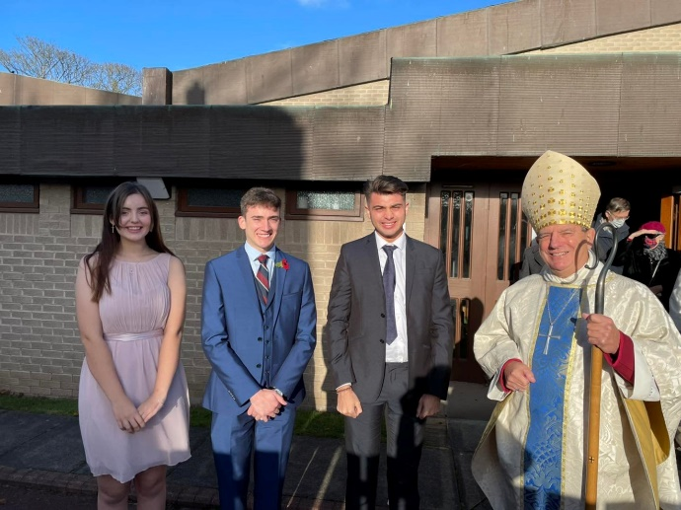

Job Description
Job Title
Children and Families Worker for Christ the King Team Parish
Areas of opportunity
The successful applicant will work with us to discern the best use of his/her time and resources, as well as providing a fresh set of eyes that may see things we have missed. Some areas where we see opportunity for development in collaboration are:
- Vision and Strategy
  - Working closely with the Team Rector and wider team to assess areas of opportunity in both our context, and our existing children and families work.
  - In collaboration with the team, to create proposals for developing existing provision, and ideas for new initiatives to be pioneered.
- Discipleship
  - Working to develop discipleship for parents, and support discipleship in the family home. This will include building on existing groups, as well as exploring the possibility of new ways of exploring and deepening in faith.
  - Developing discipleship with children as they learn and grow in faith. This will include using our existing contact with children, as well as exploring new ways of enabling children to grow and mature in faith.
- Outreach and Community
  - Engaging with our local communities to provide opportunity for community development, mutual support, and to engage with faith. This might include the provision of church-based groups and activities, or collaborating with other local groups working with children and young people.
  - Building and developing relationships with families both inside and outside our church communities.
- Schools
  - Working with the schools we have existing relationships with, leading collective worship, and offering other resources or support as appropriate to the context.
  - Exploring the possibility of engaging with other schools in the Parish.
- Team Development and Sustainability
  - Encouraging and equipping lay people to flourish in their own ministry to children and families.
  - Developing and building teams that are able to implement the vision and strategy in the long term.
What we offer
- A supportive team
  - You would have regular time to meet for supervision and prayer with the Team Rector.
  - You would attend weekly meetings with the leadership team at St Aidan’s.
  - You would be part of the wider Parish ministry team, meeting with them on an approximately monthly basis.
- Personal development
  - We would encourage you to spend time on personal development. This would include making use of Diocesan resources and support, as well as attending courses or conferences to further develop your ministry as agreed with Team Rector.
  - We would encourage you to spend time in deepening your spiritual life, including taking time for retreat and/or quiet days. We would encourage and support time for meeting with a spiritual director or other mentor if desired.

Terms and Conditions of Service
Management structure
Employed by the Parochial Church Council of Christ the King. Line managed by the Team Rector. Reporting to the District Church Councils of St Aidan’s and St Columba’s, and the Management Committee of Church in the Park.
Pay
Starting salary up to £26,500 (depending on experience and qualifications) with annual inflationary increase. Part-time applicant salary would be calculated pro-rata.
Hours
We are open to both full and part-time applicants and to a job-share. We have funding for a full-time post for 2.5 years at 35 hours a week, and the desire to extend the post further if possible. We would expect input in each of the key areas of the Parish: Brunton Park, Newcastle Great Park, Wideopen and their respective communities.
There will be an expectation of working on Sundays and some evenings and Saturdays as appropriate.
Holiday entitlement
25 days holiday per annum, plus 8 public holidays. Time off in lieu offered where appropriate.
Probationary period
Initial period of 3 months.
Notice period
During probationary period, one month by either party. After probationary period, three months by the either party.
Diversity
We understand the benefits of employing individuals from a range of backgrounds, with diverse cultures and talents. We aim to create a culture that: values difference in others and respects the dignity and worth of each individual; reflects the diversity of the nation that the Church of England exists to serve; fosters a climate of creativity, tolerance and diversity that will help all staff to develop to their full potential. We are committed to being an equal opportunities employer and ensuring that all employees, job applicants, and other persons with whom we deal are treated fairly and are not subjected to discrimination.

For further information and an informal conversation about the role, please contact: Rev’d Gerard Rundell.
Tel: 07394 792277
email: rev.g.rundell@gmail.com
address: 60 Barmoor Drive, Newcastle upon Tyne, NE3 5RG

Person Specification
Measured by: (A)pplication, (I)nterview, (R)eference
Requirements | Essential | Desirable | A | I | R
Education and Qualifications |  | Relevant qualifications related to Children’s ministry
Experience | Evidence of engaging fruitfully with Children and Families in a missional context (professional or voluntary). | Previous professional experience in a similar role.  Evidence of successfully engaging in mission and/or pioneering with Children and Families.
Skills, Character and Abilities | A committed and practicing Christian, with a desire to deepen in personal faith.  Enthusiastic and able to work well with others.  A passion for developing community and relationships both within and outside the church.  Able to communicate faith engagingly and effectively to children and families.  Able to self-motivate and work independently, as well as be a constructive part of a team.  Well organised with effective time-management.  Flexible with working hours.  Proficient with IT, and some use of social media. | Able to drive.  Some theological education.  Experience leading worship in both church and school settings.
Safeguarding | A commitment to work fully within the Safeguarding Principles and Practice of the Church of England.  A successful Enhanced DBS check.  Awareness of and willingness to comply with Data Protection laws and guidelines. | Pre-existing Safeguarding Leadership training within the Church of England.

