Going Green tips
Want to live out your faith by living sustainably and going green? Not sure where to start or just need some ideas for some sustainable swaps? The images and tips below are available for you to include in your parish newsletter, church magazine or social media, to encourage you to go green.
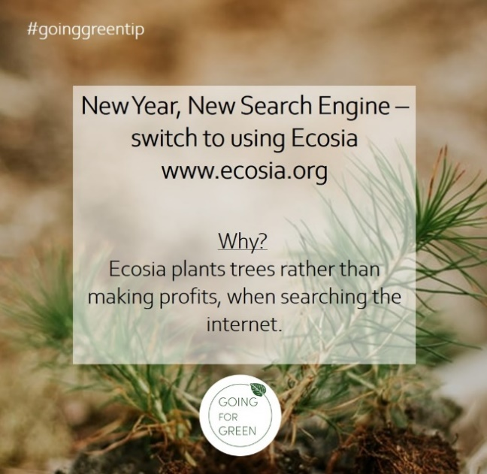
Switch to a New Search Engine – try using Ecosia www.ecosia.org

Why?
Ecosia plants trees rather than making profits, when searching the internet.

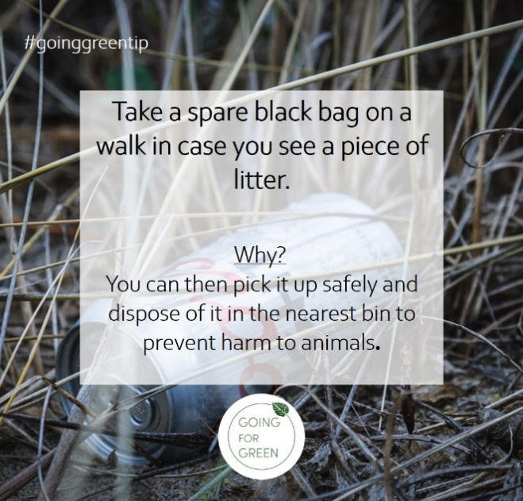
Take a spare black bag on a walk, in case you see a piece of litter.

Why?
You can then pick it up safely and dispose of it in the nearest bin to prevent harm to animals.

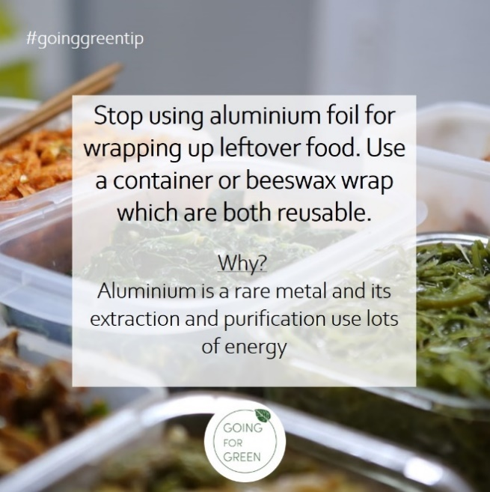
Stop using aluminium foil for wrapping up leftover food. Use a container or beeswax wrap which are both reusable.

Why?
Aluminium is a rare metal and its extraction and purification use lots of energy.
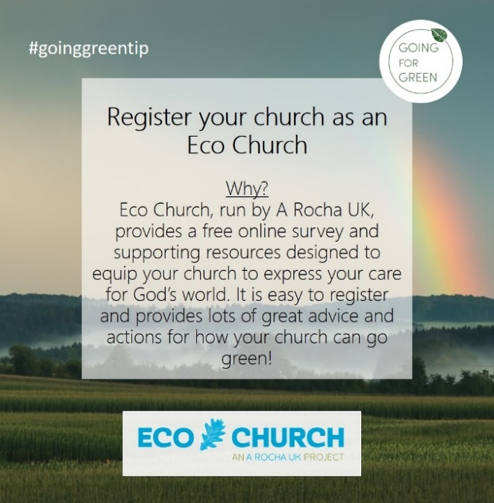
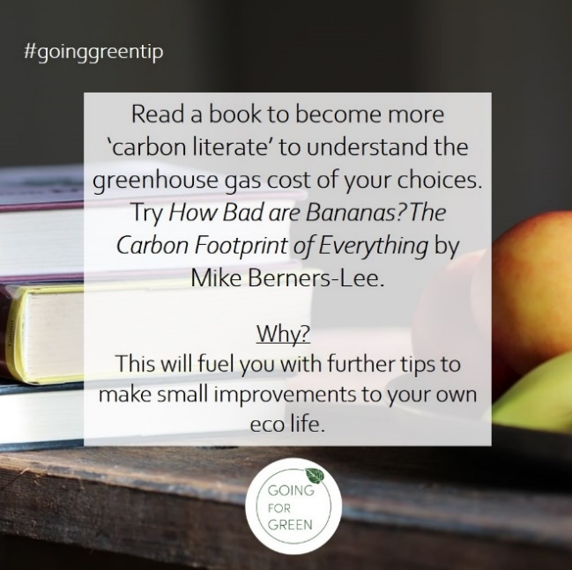
Register your church as an Eco Church

Why?
Eco Church, run by A Rocha UK, provides a free online survey and supporting resources designed to equip your church to express your care for God’s world. It is easy to register and provides lots of great advice and actions for how your church can go green! https://ecochurch.arocha.org.uk/

Read a book to become more ‘carbon literate’ to understand the greenhouse gas cost of your choices. Try How Bad are Bananas? The Carbon Footprint of Everything by Mike Berners-Lee.

Why?
This will fuel you with further tips to make small improvements to your own eco life.

