RURAL STRAND

COMMUNICATIONS AND NETWORKING

Document Control

Document Purpose
This document describes the communications and networking strategy of the Rural Strand of Newcastle Diocesan Strategy: Growing Church Bringing Hope. Effective communications and networking are both as fundamental to the success of the Rural Strand, as they are to any organisation.
The purpose of this document is therefore to
- say with whom we wish to communicate – and why
- list the partners and stakeholders with whom who we wish to network
- outline how communications and networking might be improve
I

Contact Details
Authors(s) | Helen Savage

Document History
Version | Date Updated | Updated by | Reason
0.a | 7/11/2018 | Helen Savage | Initial draft

Document Review
Name | Role | Responsible/  Accountable/  Consulted/  Informed | Version | Date

Contents
1 Document Control 2
1.1 Document Purpose 2
1.2 Contact Details 2
1.3 Document History 2
1.4 Document Review 2
2 Summary 4
3 Background 4
3.1 Context 4
3.2 Opportunities 5
3.3 Challenges/threats 5
4 Objectives 5
5 Outcomes 6
6 Description 6
7 Risks/Dependencies/Assumptions 7
7.1 Key Risks 7
7.2 Key Dependencies 7
7.3 Key Assumptions 7
8 Resources 7
9 Stakeholder Engagement 7
APPENDICES 9
I. ??? 10

Summary

Communications
The Rural Strand of Growing Church Bringing Hope reports to Diocesan Synod and to the Bishop’s Senior Staff Team. It therefore responds to requests for information and progress and aims to present its work in as clear, coherent and persuasive way as possible. The means of communication in these quite specific instances is largely dictated by those two parent bodies in line with their needs.
Beyond the need to report to these parent bodies, the success of the Rural Strand depends more widely on the effectiveness of its communications with its key constituencies: the people of the diocese, its parishes and deaneries, the wider public of the rural communities in which the church works and its partners and fellow stakeholders in the life of those communities. Communication with these groups may take a wide variety of forms including a wide variety of print (church, local, and regional press), electronic and social media as well as face to face communications in meetings, training, other events and worship.
In addition, there are a number of significant groups with whom the Rural Group communicates including the Diocesan Rural Conversations Network and groups in and beyond the region both in the Churches and beyond it, such as local, regional and national Government, landowners, public bodies such as the National Park, Areas of Outstanding Natural Beauty, public agencies such as Historic England, the Heritage Lottery Fund and Natural England, special interest groups including the National Farmers Union, schools , colleges and universities – in fact anyone and everyone who care about the rural communities of North East England.
Networking
From the last paragraph especially it can clearly be seen that the task of communications overlaps with that of networking. Indeed it could be said that communications describes the process by which networking is made effective, as well as having a broader, slightly less focused function of disseminating ideas and information.

Background

Context
The Rural Strand of Growing Church Bringing Hope aims to re-imagine rural ministry, particularly to create mission and ministry teams with new pastoral structures. These need to be responsive to local need, making use of a variety of modes and kinds of ministers and workers as appropriate, and be resilient, enabling a sustainable, positive church presence in every rural community.
The goals for the strategy are that in five years’ time the rural church will be:
• Worshipping locally and with openness to new patterns of worship, new styles of worship and fresh types of congregation;
• Confident and engaged with developing the church’s life and mission (this will include training for lay and ordained, the development of discipleship, the nurture of lay worship leaders and the growth of clergy able to focus on delivering the vision;
• Regarded by other institutions, communities and individuals as a significant partner/player in the development of local communities;
• Valued – by itself and others – as a sacred space that holds and shares the Christian story and its heritage in Northumbria and beyond;
• A church that has embraced a holistic and varied understanding and practice of growth: in numbers of people who value, respect and engage with their parish church; in numbers of those who are positively impacted by the church; and in openness to how church growth might happen.
To achieve these things, and to demonstrate that they have been achieved, requires a strategy which communicates its findings effectively and imaginatively.

Opportunities

The Rural Strand has access to diocesan communications: the diocesan website, The Link and electronic networks such as the Rural Conversations Network. Through its impressive series of contextual workshops it has established its own new network of people concerned to explore rural issues and theology. Above all, through its own members and more especially the people with whom it works in the parishes of the diocese it has access both to an extraordinarily wide range of networks and partners and with them, to the widest possible range of means of communication.

Challenges/threats

Time, lack of clout, expertise and money are the biggest challenges and threats that face the Rural Strand approach to communications. The Rural Group’s Guiding Coalition depends largely on either volunteer time or that of hard-pressed professionals who have many other responsibilities. It has limited access to diocesan channels of communications – and less than it would like (website and paper) and no editorial control. Whilst the Group contains individuals who are highly skilled at communications, the combined skill-set nevertheless falls short of what is desirable and it has little money or other recourses at hand to pay for others to do what it can’t do – or has no time to do so. Pressure of (a lack of) time restricts the effectiveness of networking.

Objectives

Communications
- Report regularly on the work of the Rural Strand on the Diocesan website and newspaper.
- Dissemination of the results of the case studies to inform better training, ensure better/more effective deployment and governance, and to improve performance in other rural parts of the diocese.
- Stimulate wider debate about the sustainable future of the church in rural communities and the theology that informs it.
- Maintain appropriate contact and channels of communication with partners and key stakeholders

Networking
Maintain and expand the widest possible network of partners, existing and potential stakeholders.

Outcomes

- Regular reporting in and through diocesan media.
- Better, more focused training.
- A lively, better-informed, theologically-engaged understanding of the rural church within the diocese at all levels (bishop’s staff, diocesan synod, deaneries and parishes).
- Better informed, more imaginative and confident deployment and governance.
- A wider network of partners with clearer focus and understanding of where interests overlap.
- A deeper appreciation of the constraints under which partners and stakeholders work.

Description

Communications
- Appointment of a member of the Rural Strand Guiding Coalition to take lead responsibility for communications, supported by a budget and by the diocesan communications team. This will help ensure that regular reporting takes place and will establish a clear line of responsibility with and to other diocesan bodies and officers.
- The publication of an annual report on the rural church as a supplement to The Link.
- A continuing programme of contextual workshops, reported in detail on the diocesan website and where appropriate supported by press releases.
- Agreed methods and forms of writing up the case studies to enable learning from them to be accessed by all the parties who could benefit from it, including senior management and peer groups.
- A programme of educational events and materials designed to reflect on the learning from the case studies aimed at specifically and clergy and other leaders and integrated into the Continuing Ministerial Education programme.
- Academic papers disseminated through the Rural Theology Association and others to stimulate a wider debate about the rural church and its future.
Networking
- Establishment of a diocesan directory of rural partners and stakeholders with key contacts and descriptions of their remit and interests.
- A programme of educational events from clergy and leaders about how to work more effectively, critically and imaginatively with partners and stakeholders.

Risks/Dependencies/Assumptions

Key Risks
Description | Importance | Mitigation | Owner
 | Low/Med/High
There may not be someone willing to take on the communications role in the Guiding Coalition
So much depends on the goodwill of other individuals and groups in the diocese
Communications is time consuming

Key Dependencies
Dependency Description | Importance | Mitigation
The diocesan communications team | Low/Med/High
The CME officer
The willingness of serving clergy and management to take heed!

Key Assumptions
Assumption Description | Importance | Mitigation
That the results of case studies will be heeded | Low/Med/High
That everyone in the diocese really believes that communications are a good thing
That other individuals, organisations and stakeholders wish to become partners

Resources

- An individual on the Guiding Coalition willing take responsibility for communications.
- Time and money to evaluate, write up and prepare educational materials – and to deliver them.
- Individuals with the time and resources to plan and deliver other events and the directory of network partners as listed above.

Stakeholder Engagement
The key stakeholders have been identified and assessed based upon their level of interest and the level of influence they exert in achieving the stated outcomes.
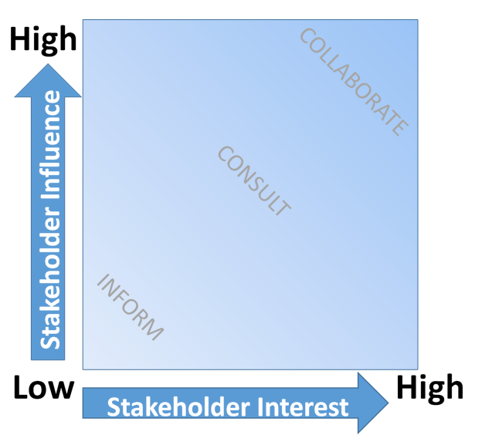

Stakeholder | Interest | Influence | Engagement Strategy
Name | LOW/MED/HIGH | LOW/MED/HIGH | How to engage and communicate with

APPENDICES

???

