Parish Church of St James, Riding Mill
Risk Assessment
Springtingle (indoors and outdoors)
Author and Health & Safety Coordinator:
Rev’d Diana Johnson

Risk area: | Parish Church of St James, Riding Mill  Springtingle (indoors and outdoors) Risk Assessment

Assessment  performed by: | Diana Johnson
Activities by: | Parochial Church Council
Authority: | Parish Church of St James, Riding Mill Parochial Church Council. Parish telephone 01434 682 768. http://www.stjameschurchridingmill.com/

General hazards
Potential Hazards  in this Risk Area | Estimated Risk Level (BEFORE control measures considered) |  |  | Control measures  that could be used to reduce the risk | Final Risk Level  (after control measures introduced)
 | Unacceptable | Tolerable | Acceptable |  | Unacceptable | Tolerable | Acceptable
Violence or aggression towards volunteers | ✓ |  |  | Volunteers work all in one place or where they can monitor one another’s well-being. People not to be alone with children or adults such as parents |  | ✓
Accidents, including major accident , falls and collisions, and illness. In the churchyard, especially:  Trip hazards, overhead branches, etc., potentially slippery paths, uneven ground, poisonous plants, strangers. | ✓ |  |  | First-aid equipment is to be readily accessible (Activity leaders (DJ) to check please)  Remind participants of hazards, adults supervising children and watching out for strangers, first aid available in Vestry.  Trip hazards - make sure that routes are clear, especially if people are moving fast and not necessarily looking where they are going. Some trip hazards will always be there, so everyone needs to be aware that outside is not as controlled as inside and to watch where they are going.  Unexpected objects at head height - there will be more of these outside than indoors. Remember that people are different heights so look above and below your own eye level when reviewing a site.  Slippery surfaces - check surfaces out, especially on damp days, and decide if any particular areas or routes need to be avoided, cleared or made safe.  Traffic - this is particularly important when you are working with children. Make sure that the two exits to Church Lane roads from Churchyard, and behind the shed particularly, are secure or well supervised.  Stranger danger - you are using places that are open to the public, so be aware of any people approaching your group that you do not know, especially when working with children or vulnerable adults.  Animals - again in public spaces there may be animals in the area that you may not be able to control. Be aware that you need to be able to protect the members of your group.  Poisonous and irritant plants - if you are accompanying very young children look out for poisonous plants that might seem attractive to touch or to eat. Other plants may just be an irritant, such as stinging nettles, but might cause a few tears along the way.  Allergies - some people have allergies that can affect them badly at certain times of year, such as hay fever, and this may well stop them from enjoying being outdoors. Check that children have any medication with them if needed; if they are very young, you should know how and when it needs to be administered. You also need to be aware of any food allergies if you are eating outside.  In the event of a major emergency ambulance should be called immediately. An adult volunteer to go to entrance of Church or Old Playground car park to guide ambulance crew. Ensure good access to telephones, which includes volunteers mobiles as well. |  |  | ✓
Security of children compromised, if children are present. Children have a lesser awareness of risk and so require special thought to be given to mitigate any risk. | ✓ |  |  | Security of children compromised, if children are present. Children have a lesser awareness of risk and so require special thought to be given to mitigate any risk.  Note especially:  Safeguarding  This parish recognises that the welfare of children, young people and vulnerable adults is paramount and that we have a duty of care when they are in our charge. Furthermore this is the responsibility of all church members.  We will do everything that we can to provide a safe and caring environment whilst they attend our activities.  We will:  - Treat all children, young people and vulnerable adults with respect and celebrate their achievements  - Recruit and select all those working with children, young people and vulnerable adults on our behalf in accordance with Diocesan Safer Recruitment procedures  - Provide a code of conduct for all staff to include the assessment of risk for key roles when working with children, young people and vulnerable adults  - Respond to concerns and allegations without delay in accordance with Diocesan Safeguarding procedure  The PCC has adopted the Church of England’s policies and best practice on safeguarding which may be found on the Church of England’s website and the Diocese of Newcastle’s website.  For more information about Riding Mill’s Church Safeguarding policy please click here. | ✓
Risk from electrical equipment, incorrect use of equipment and use of defective equipment  (Mike Pritchard to note) |  | ✓ |  | Any electrical equipment, such as music players, visually checked for safety and loose cables taped down or covered by heavy matting.  Report any electrical defect immediately to the Activity leaders (DJ) and take it out of use. Clearly label any defective equipment to prevent further use.  Only a competent person may undertake any work on electrical equipment, including changing fuses and plugs. |  |  | ✓
Risk of cuts from broken glass | ✓ |  |  | Ensure any broken glass is cleared immediately.  Always wear suitable gloves to handle broken glass. Always clear broken glass with suitable equipment (i.e. dust pan and brush etc.) Always dispose of broken glass into suitable container. |  |  | ✓

Thank you everyone for agreeing to help with the Springtingle on Bank Holiday Monday. This message is to confirm what we have said and bring it to one place for reference. We will start at 10.30am, so if those who need to set up, or who are on first, could aim to be there in good time that will be helpful. In any case, the more of us who are around throughout the better for safety. That will be especially so in the Easter Egg hunt in the churchyard and for juice and biscuits.

We will meet in the church, though the Church Cottage will be available too. Jenny, in particular, could you tell me whether you prefer the Church Cottage or the Choir Vestry for crafts?

The rough timings are:

10.30-10.50 Ruth from RMOPS – Teach and sing opening Song
10.50-10.55 Changeover
10.55-11.15 Story – Rev’d Diana from story bag.
11.15-11.20 Changeover
11.15-1135 Craft: Jenny Mathers
11.35-11.40 Changeover
11.40-12.00 Easter Egg Hunt: Salianne Duff and friends
12.00-12.15 Choc bix and juice supplied by Diana (individually wrapped: 30-35 covers) – likely in Church Cottage for a change of venue
12.15-12.30 Final singing taught and led by Clare Coles with the help of her daughter.
12.30 Children depart; clear up and thanks.

Gwyn: would you be willing to create and take a register of children, declared allergies and parental emergency contacts details on arrival?
Suz: I do not have a contact for Clare so if you have one could you forward this please?
David: please would you check the risk assessment?

I have no idea at all how popular (or otherwise) the morning will be. If numbers are large we can run the craft and story activities concurrently and then swap around and repeat.

Risks associated with catering (Coffee after the service)
Some Potential Hazards  in this Risk Area | Estimated Risk Level (BEFORE control measures considered) |  |  | Control measures  that could be used to reduce the risk | Final Risk Level  (after control measures introduced)
 | Unacceptable | Tolerable | Acceptable |  | Unacceptable | Tolerable | Acceptable
Lack of personal hygiene on part of volunteers | ✓ |  |  | Hand washing before and after |  | ✓
Visitors and Volunteers  Hazards: allergic reaction to refreshments; | ✓ |  |  | Clear labelling of ingredients used in refreshments (including wrapped sweets and juice); Provide suitable labels of ingredients. |  | ✓
Inadequate operating instructions for equipment |  | ✓ |  | Volunteers to be briefed by event organiser |  |  | ✓
State of electricity, gas and water supplies, if present, is unsafe | ✓ |  |  | Activity organiser to conduct visual check |  |  | ✓
Spillages may cause burns or other hazards |  | ✓ |  | Action in case of spillage is to wipe up immediately  Risks mitigated by removing trip hazards in refreshment area, paying particular attention to area near to kettles/urns.  Check refreshment area (Church Cottage) before event.  Only volunteers who can carry a tray safely will be asked to do so.  Crowding in refreshment area to be monitored and where necessary, people will be asked to move outside the Church Cottage (but still in the fenced area) area. |  | ✓
Storage arrangements not hygienic | ✓ |  |  | Tables wiped down by antiseptic cleaner or paper coverings used. Food stored in cool boxes or fridges. |  | ✓
Poor access to work areas in kitchen |  | ✓ |  | Supervision by event organiser |  |  | ✓
If one of these hazards is identified in an event, please tick ( ✓) the level of risk, and indicate the date when any consequent controls were put in place. For additional hazards and/or control measures, please use the table below.

Parish Church of St James, Riding Mill Handy Guide for Assessing Risk

Remember, risk is a mix of two factors: likelihood and consequence. This is how to assess them at St James’s Parish Church:
Step One: think about the likelihood.

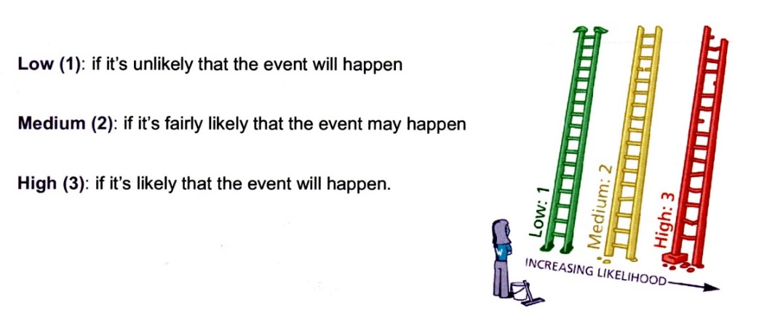
Step Two: think about the consequences.

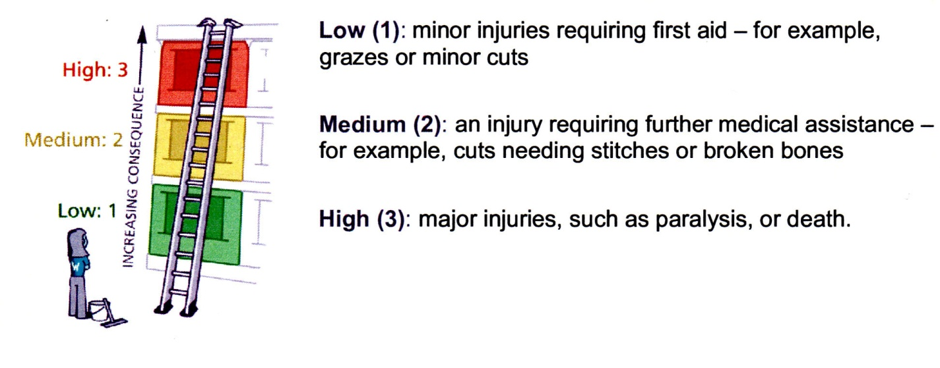

Step Three: put the likelihood together with the consequences to assess whether the risk is acceptable, tolerable or unacceptable.

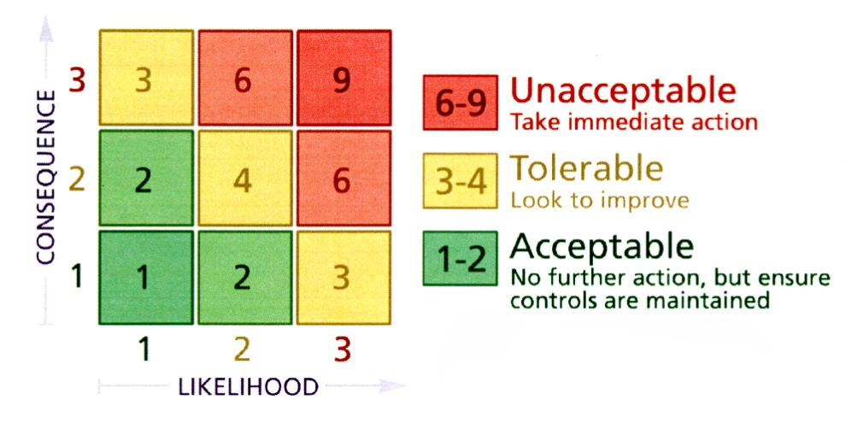

Now, ask yourself whether you can reduce the risk by introducing risk control measures. Take advice from Diana Johnson or a PCC member if you are unsure.

Employees informed of risk assessment via all of the following means: | 1. Event organiser completing Risk Assessment, with advice from Health & Safety Coordinator  2. Church Warden or event organiser to check through Risk Assessment and any supporting documents. All relevant Committee members will be issued with a copy of these documents by the event organiser.  3. Urgent announcement (if deemed necessary) to the public and/or volunteers should there be any further risk identified in the lead up to the event or at the venue.  5. Volunteers on duty to be briefed by the activity organiser on activity arrangements and on Risk Assessment.  6. All H&S incidents to be logged in Church Accident Book held in the Vestry
Volunteers to report newly-identified hazards via: | The event organiser, Church Warden or a PCC member

Any safeguarding incident / concern must be reported immediately to the Parish Safeguarding Officer David Mackenzie

RISK ASSESSMENT COMPLETED BY Event Organiser
Date: | 12th April 2022 | Event Organiser to sign: | 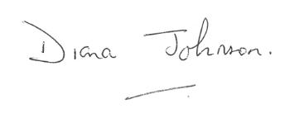
RISK ASSESSMENT CHECKED BY Church Warden
Date: |  | Church Warden (in this case) to sign:

