Part B (to be returned to CMFO by reviewer)

Report to be returned to c.pacitti@newcastle.anglican.org by reviewer

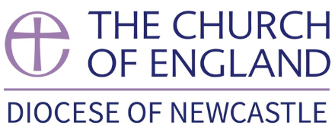

Ministerial Development Review for Licensed Clergy.

Name of Reviewee:
You cannot bear the weight of this calling in your own strength, but only by the grace and power of God. Pray therefore that your heart may daily be enlarged and your understanding of the Scriptures enlightened.
Pray earnestly for the gift of the Holy Spirit.

Objectives
Review
What were the objectives that were agreed in your previous MDR discussion, and how did you get on?

Looking forward
Please think of three objectives for the coming year, including one personal objective if you wish. These should be meaningful and achievable in the next year. Please be realistic about your own capacity (and where necessary what you may need to ‘lay down’ in order to protect this). Objectives are not designed to become an additional burden but an ongoing part of your formation. Where appropriate the CMFO will be able to provide you with advice on available funding or access to training possibilities.
For each one, please describe:
- What the objective is, and why you have chosen it
- How and when do you hope you will achieve it? How will it be clear to you that you have achieved it?
- Whom will you need to accompany you in achieving it, and what resources do you think you will need?

1.

2.

3.

What CMF courses or training or other replenishment have you undertaken in the last year?

What training or support do you see yourself needing to increase your potential or help you move into new possibilities / expand your capacity?
(If the answer is “none”, please give your reasons.)

(The response given in this box will be followed up with you by the CMFO.)

FOR CMFO USE:
Confirm that safeguarding training is up to date
Confirm details are on the National Clergy Register

