Parish Church of St James, Riding Mill
Risk Assessment
Eve of All Hallows (Hallowe’en) Light Station
Author and Health & Safety Coordinator:
Rev’d Diana Johnson

Risk area: | Parish Church of St James, Riding Mill  Eve of All Hallows (Hallowe’en) Light Station in the Community Quiet Area  Risk Assessment

Assessment  performed by: | Diana Johnson
Activities by: | Parochial Church Council or other small group
Authority: | Parish Church of St James, Riding Mill Parochial Church Council. Parish telephone 01434 682 768. http://www.stjameschurchridingmill.com/

Wet weather programme: operate out of West Porch, fronting on to Church Lane.

Potential Hazards  in this Risk Area | Estimated Risk Level (BEFORE control measures considered) |  |  | Control measures  that could be used to reduce the risk | Final Risk Level  (after control measures introduced)
 | Unacceptable | Tolerable | Acceptable |  | Unacceptable | Tolerable | Acceptable
Consumption of alcohol (authorised or not) can reduce awareness of hazards, leading to degraded decision making and risky behaviour |  | ✓ |  | Consumption of mulled wine for adults limited to specific time and place.  Use tip-proof disposable paper cups with lids |  |  | ✓
Violence or aggression towards volunteers | ✓ |  |  | Volunteers work all in one place or where they can monitor one another’s well-being. People not to be alone with children or adults such as parents |  | ✓
Accidents, including major accident , falls and collisions, and illness | ✓ |  |  | First-aid equipment is to be readily accessible (Churchwardens to check please)  Behaviour monitored throughout so that no one is hurt through e.g. too boisterous behaviour. All volunteers knowing who to consult/check with/report to if there is an incident or someone becomes ill or there is an accident (Churchwardens or clergy)  First aid kit at hand. Whereabouts to be known to everyone.  In the event of a major emergency ambulance should be called immediately. An adult volunteer to go to entrance of Church or Old Playground car park to guide ambulance crew. Ensure good access to telephones, which includes volunteers mobiles as well. |  |  | ✓
Security of children compromised, if children are present. Children have a lesser awareness of risk and so require special thought to be given to mitigate any risk. | ✓ |  |  | Security of children compromised, if children are present. Children have a lesser awareness of risk and so require special thought to be given to mitigate any risk.  Note especially:  Safeguarding  This parish recognises that the welfare of children, young people and vulnerable adults is paramount and that we have a duty of care when they are in our charge. Furthermore this is the responsibility of all church members.  We will do everything that we can to provide a safe and caring environment whilst they attend our activities.  We will:  - Treat all children, young people and vulnerable adults with respect and celebrate their achievements  - Recruit and select all those working with children, young people and vulnerable adults on our behalf in accordance with Diocesan Safer Recruitment procedures  - Provide a code of conduct for all staff to include the assessment of risk for key roles when working with children, young people and vulnerable adults  - Respond to concerns and allegations without delay in accordance with Diocesan Safeguarding procedure  The PCC has adopted the Church of England’s policies and best practice on safeguarding which may be found on the Church of England’s website and the Diocese of Newcastle’s website.  For more information about Riding Mill’s Church Safeguarding policy please click here. | ✓
Visitors and Volunteers  Hazards: allergic reaction to refreshments and sweets given out to children | ✓ |  |  | Clear labelling of ingredients used in refreshments (including mulled wine);  Provide suitable labels of ingredients. |  | ✓
Risk from electrical equipment, incorrect use of equipment and use of defective equipment |  | ✓ |  | Any electrical equipment, such as music players, visually checked for safety and loose cables taped down, routed safely or covered by heavy matting.  Report any electrical defect immediately to the Churchwardens and take it out of use. Clearly label any defective equipment to prevent further use.  For outdoor connections:  - Ensure a residual current device is in place to safeguard the circuit.  - Consider whether low voltages can be substituted  - Use weatherproof boxes for cable plugs and sockets exposed to the elements.  Only a competent person may undertake any work on electrical equipment, including changing fuses and plugs. |  |  | ✓
Risk of cuts from broken glass | ✓ |  |  | Ensure any broken glass is cleared immediately.  Always wear suitable gloves to handle broken glass. Always clear broken glass with suitable equipment (i.e. dust pan and brush etc.) Always dispose of broken glass into suitable container. |  |  | ✓
Inadequate fire equipment | ✓ |  |  | Fire equipment checked by event organisers.  Any hanging used to dress the venue will not obstruct fire points, emergency exits or any safety signage. |  |  | ✓
Lack of fire awareness | ✓ |  |  | Volunteers present know the fire drill procedure. Assembly point to be in front of the Church Cottage; Churchwardens or clergy to take charge. No one to return to any of the buildings until it is declared safe to do so. If there is a major/catastrophic emergency during the event use volunteers’ local knowledge to gain entry an alternative venue, such as the Church Cottage or Millennium Hall, in case everyone has to transfer to wait collection. Also easier to supervise - and away from the wet if it is raining. Telephones to be made available e.g. volunteers mobiles.  Activity organiser is to give a safety briefing at the start of the event. This is to include:  - Point out fire exits.  - Inform people of the location of the assembly area.  - Remind parents that in an emergency they should not take children away until everyone has been accounted for.  - Aisles and walkways to be kept clear of obstructions.  If the event includes a projector and screen, consider using a PowerPoint presentation which may be shown before the event as people fill the seats, instead. |  |  | ✓
Poor access to fire exits | ✓ |  |  | Routine announcements re fire exits (see above)  Fire exits to be checked that they are clear on the inside and outside. Access to fire exits to be kept clear inside the venue. If the Chancel is being used then unlock the East doors to the outside from the toilet area prior to the event. |  |  | ✓

Parish Church of St James, Riding Mill Handy Guide for Assessing Risk

Remember, risk is a mix of two factors: likelihood and consequence. This is how to assess them at St James’s Parish Church:
Step One: think about the likelihood.

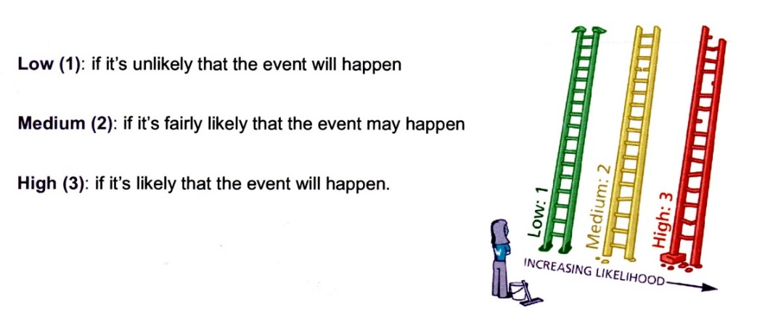
Step Two: think about the consequences.

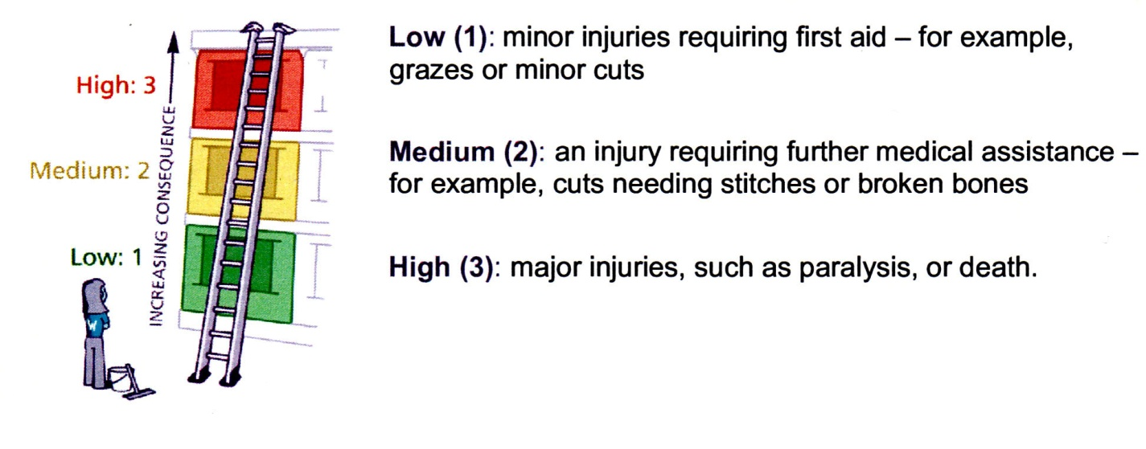

Step Three: put the likelihood together with the consequences to assess whether the risk is acceptable, tolerable or unacceptable.

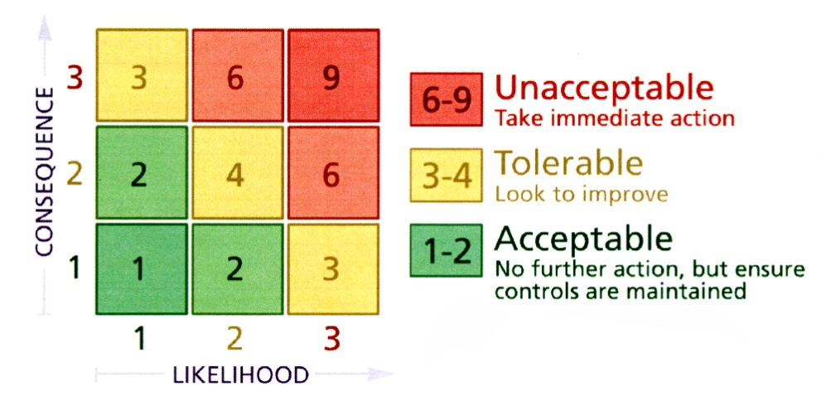

Now, ask yourself whether you can reduce the risk by introducing risk control measures. Take advice from Diana Johnson or a PCC member if you are unsure.

Participants informed of risk assessment via all of the following means: | 1. Event organiser completing Risk Assessment, with advice from Health & Safety Coordinator  2. Church Warden or event organiser to check through Risk Assessment and any supporting documents. All relevant Committee members will be issued with a copy of these documents by the event organiser.  3. Urgent announcement (if deemed necessary) to the public and/or volunteers should there be any further risk identified in the lead up to the event or at the venue.  5. Volunteers on duty to be briefed by the activity organiser on activity arrangements and on Risk Assessment.  6. All H&S incidents to be logged in Church Accident Book held in the Vestry
Volunteers to report newly-identified hazards via: | The event organiser, Church Warden or a PCC member

Any safeguarding incident / concern must be reported immediately to the Parish Safeguarding Officer David Mackenzie

RISK ASSESSMENT COMPLETED BY Event Organiser
Date: | 29th Oct 21 | Event Organiser to sign: | 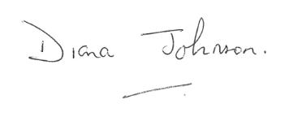
RISK ASSESSMENT APPROVED BY Church Warden or Priest in Charge
Date: |  | Church Warden or Priest in Charge to sign:

