First Incumbents Termly Residential at Shepherds Dene, Tues 16th – Weds 17th January

Next in the programme for those in First Incumbency positions. Theme – Appreciative Inquiry and Asset Based Community Development (ABCD) with Dr Val Barron.
Open to First Incumbents (who have been emailed).

Journeying Together Gently with Paul Hutchinson. Online, Tuesdays 7-9pm. Starts 30th January then 27 Feb, 19 March, 30 April, 28 May, 25 June

Open to Clergy (limited to 12 places)
A unique monthly online gathering to explore, deepen and practice the holy art of hosting.
The Christian tradition often invites us to welcome - the stranger, the widow, the vulnerable, the neighbour, the exile.
We are also called to welcome (or host) ourselves – to care for ourselves, to pay attention to our particular needs.
We will explore how to host ourselves using a creative process, involving
poetry
image
prayer
breath
gentle conversation
Register here

Theology& seminar series at Newcastle Cathedral, Thursdays 3.30-5pm 1st Feb, 7th March, 2nd May

Open to all – please email c.pacitti@newcastle.anglican.org to express an interest.
Continuing this popular series of talks exploring the intersections between theology and ‘other’ disciplines.
1st Feb Jaimee Summers: Theology & Neurodiversity: God's Gift of Sparkly Brains
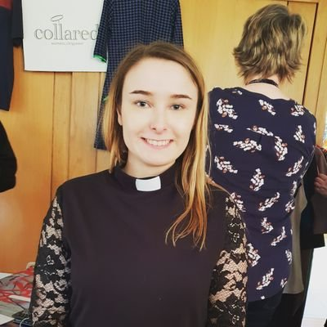

Jaimee (they/them) is a vicar in Southwark Diocese with their dog, Rev Rosie. They spent their curacy in Epping, Essex, and trained in Cuddesdon Theological College. They are passionate about disability theology, queer theology, hobbits & wildlife. They once received a tiny, tiny trophy for being the shortest priest in England (status thus far unchallenged).

7th March Tim Evans: Theology and Practicing Radical Presence - exploring an asset based community development lens to engaging our communities
Tim has been a trained youth and community worker for 30 years and was previously CEO of a small national Christian youth and community work organisation Worth Unlimited for 19 years. He has M.A's in Community Education and in Theological Education. For 20 years he has lived intentionally on an estate in east Birmingham developing youth work and as part of his local Anglican church helped initiate and manage intergenerational community building work using an asset based community development approach. He has been a trustee of several charities including Thrive Together, a joint venture between Birmingham Diocese and the Church Urban Fund to enable churches to tackle issues of poverty, Birmingham YMCA tackling youth homelessness, Darlington Area Churches Youth Ministry supporting youth work and mental health support for young people, and UCC building a school providing education for underprivileged children in Ghana.
Now running a training, coaching and consultancy company, Curating Connections that supports churches, organisations, institutions and practitioners in delivering quality youth work and developing an asset based community development approach including trauma informed and (hopefully) theologically literate approaches as appropriate. A Senior Associate of Nurture Development who work in 35 countries animating institutions, practitioners and communities in adopting an ABCD approach. A Practice Lead for Loconomy that seeks social justice through developing local economies using an asset based approach, and engaging communities in community regeneration programs.
With his wife Ria, they have been foster carers for 21 years, have two daughters and a dog and he enjoys cycling, tennis, squash and painfully being a Fulham supporter!

2nd May Malcolm Guite and Tim Boniface: Theology, Imagination and the Arts
This lecture and discussion explores the intersection between Christian thought, artistic endeavour and the role of the imagination in faith. An exciting wide-ranging session led by renowned priest, poet and theologian Malcolm Guite, along with jazz performer, composer and theologian Tim Boniface.
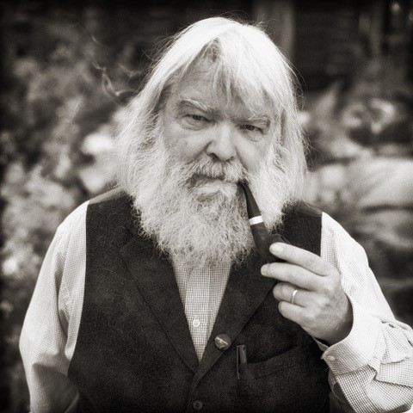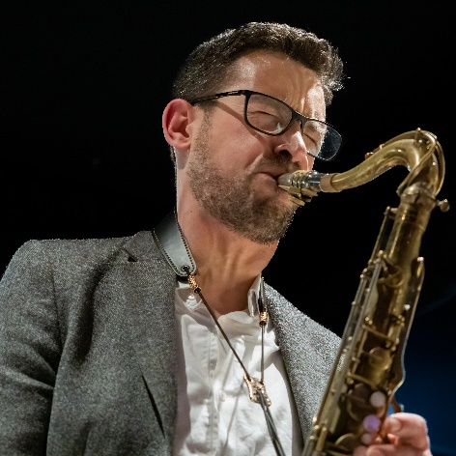
Malcolm Guite is a poet and priest, and Life Fellow of Girton College, Cambridge. He lives in Norfolk, England, and lectures widely in England and North America on Theology and Literature. His books include Sounding the Seasons; Seventy Sonnets for the Christian Year (Canterbury 2012). The Singing Bowl; Collected Poems (Canterbury 2013) and Parable and Paradox (Canterbury Press 2016) and Mariner: A Voyage with Samuel Taylor Coleridge (Hodder 2017) After Prayer (Canterbury Press 2019) and The Word Within the Words (DLT 2021) and Lifting The Veil, Square Halo, 2021.
In 2023 he was awarded the Archbishop Lanfranc Medal for Education and Scholarship by the Archbishop of Canterbury.
He has a Youtube series called ‘A Spell in the Library’ at https://www.youtube.com/c/MalcolmGuitespell
Tim Boniface is a jazz saxophonist, pianist, composer and educator; and a priest serving as Chaplain to Girton College in Cambridge. Alongside his regular collaborations with numerous leading jazz musicians on the UK scene, Tim’s original jazz suites explore broad scriptural themes through jazz composition and improvisation. His critically acclaimed works The Eight Words (2016) and The Infant (2019) have now been followed by a new work, Psalter: Themes for Peace, to be premiered at St Albans Cathedral in January 2024. Tim’s theological work explores Christian approaches to transcendence (Jesus Transcendence and Generosity, Fortress, 2018) and the intersection of theology and arts.

From beginning to end: Leading a Retreat with Paul Hutchinson weekend at Shepherds Dene. Friday 1st- Saturday 2nd March.
Open to Clergy and Readers (limited to 12 places)

A practical and experiential exploration of how to lead a spiritual retreat
Times: Friday 3pm – Saturday 3pm
This fun and hands-on residential will include the following subjects:
- Deciding and being guided by your aim
- Who should attend? (Participants)
- Preparation
- Group dynamics
- Shape and content
- Process and pace
- Managing expectations
- Venue, setting, practical stuff
- Working with difficult situations
- Warm-ups, endings and evaluations.
Register here

Rural Church Study Day: Priestly Leadership in the Rural Church
– Tuesday 5th March, 10am-4pm. Venue: Hebron St. Cuthbert’s.
Open to Licensed Clergy in (or with an interest in) rural ministry.

Programme
Welcome and Introduction
- Dr Ce Pacitti, Reader, CMF Officer
- The Ven Dr Catherine Sourbut Groves, Archdeacon of Lindisfarne
- The Rt Revd Mark Wroe, Bishop of Berwick

The Rural Church: Where have we come from,
and where are we going?
- Prof Alec Ryrie, Reader, Professor of the History of Christianity at Durham University

Lunch provided (£5 requested donation in cash on the day)

What kind of leadership is needed
to shape the future of rural churches
and respond to the needs of the rural communities
of which they are part?
- The Revd Dr Gill Alexander, Interim Minister at Haydon Bridge, Formerly Chief Executive at Hartlepool Borough Council

A Rural Church Learning Community?
How might rural licensed clergy continue to learn together,
in order to ‘help the church to be the church’?

Register here

Passiontide Reflections on ‘Black Lives Matter’ in the light of the Cross and the Resurrection. A Seminar by the Revd Professor Kelly Brown Douglas (from the US on zoom): Saturday 23rd March, 2024, 1.00 pm. Venue: Newcastle Cathedral.
Open to Clergy and Laity from Durham and Newcastle Dioceses.
Register here

Diocesan Licensed Clergy Retreat 16th-17th July 2024. Venue: Hexham Abbey.
“Inhabiting the Bible through story: The use of imagination in interpreting the Bible.”
Led by Canon Dr Paula Gooder.
Open to Licensed Clergy.
Overnight accommodation available.
Book tickets and accommodation here

Coming up….

Saturday 27th April. Study day on Environmentally Focussed Worship – morning training session led by Rev’d Helen Bent (Arthur Rank Centre and Transforming Worship) and then afternoon worship demonstrating praxis. Collaboration with Transforming Worship North to be advertised to Carlisle, Durham and Newcastle dioceses. Further detail to follow….

