Parish Church of St James, Riding Mill
Risk Assessment
General Activities in the Church Cottage
Author and Health & Safety Coordinator:
Rev’d Diana Johnson

Risk area: | Parish Church of St James, Riding Mill  General Activities in the Church Cottage  Risk Assessment

Assessment  performed by: | Diana Johnson
Activities by: | General Activities in the Church Cottage
Authority: | Parish Church of St James, Riding Mill Parochial Church Council. Parish telephone 01434 682 768. http://www.stjameschurchridingmill.com/

Potential Hazards  in this Risk Area | Estimated Risk Level (BEFORE control measures considered) |  |  | Control measures  that could be used to reduce the risk | Final Risk Level  (after control measures introduced)
 | Unacceptable | Tolerable | Acceptable |  | Unacceptable | Tolerable | Acceptable
Emergency evacuation of Church Cottage. |  | ✓ |  | For those unfamiliar with Church Cottage it may be necessary to explain that emergency evacuation is by the main door through which they entered. In the lobby area there is a copy of a guidance document on how to summon help in different emergency situations.  THE FIRE ASSEMBLY POINT IS ON THE CORNER OF THE CAR PARK, BESIDE THE SPINNEY. |  |  | ✓
Dealing with abusive members of the public or colleagues whilst involved in church duties. |  | ✓ |  | In the first instance raise your concern(s) immediately with the priest in charge, organiser or churchwarden team. Exceptionally, the Parish Safeguarding Officer will manage your concern. |  | ✓
Accidents, including major accident , falls and collisions, and illness |  | ✓ |  | First-aid equipment is to be readily accessible  Any slip hazards such as spilt water must be cleared immediately.  Any damage or defects in floor coverings must be reported to the churchwarden team who will assess and correct as necessary.  Trailing electrical cables and other trip hazards must be removed immediately.  Obstacles to normal movement in and around church cottage must be removed immediately and must never be allowed to obstruct the emergency evacuation route.  All church officers and volunteers must be constantly mindful of the special needs of children, the elderly and the infirm and offer advice/ help on negotiating the entrance into the cottage. Also special attention needs to be paid to children, the elderly and infirm once they leave the cottage and reach Church Lane because of the hazard from traffic..  In the event of a major emergency ambulance should be called immediately. An adult volunteer to go to the Old Playground car park to guide ambulance crew. Ensure good access to telephones, which includes volunteers mobiles as well. |  |  | ✓
Security of children compromised, if children are present. Children have a lesser awareness of risk and so require special thought to be given to mitigate any risk. | ✓ |  |  | Security of children compromised, if children are present. Children have a lesser awareness of risk and so require special thought to be given to mitigate any risk.  Note especially:  Safeguarding  This parish recognises that the welfare of children, young people and vulnerable adults is paramount and that we have a duty of care when they are in our charge. Furthermore this is the responsibility of all church members.  We will do everything that we can to provide a safe and caring environment whilst they attend our activities.  We will:  - Treat all children, young people and vulnerable adults with respect and celebrate their achievements  - Recruit and select all those working with children, young people and vulnerable adults on our behalf in accordance with Diocesan Safer Recruitment procedures  - Provide a code of conduct for all staff to include the assessment of risk for key roles when working with children, young people and vulnerable adults  - Respond to concerns and allegations without delay in accordance with Diocesan Safeguarding procedure  The PCC has adopted the Church of England’s policies and best practice on safeguarding which may be found on the Church of England’s website and the Diocese of Newcastle’s website.  For more information about Riding Mill’s Church Safeguarding policy please click here. |  | ✓
Risk from electrical equipment, incorrect use of equipment and use of defective equipment |  | ✓ |  | Any electrical equipment, such as music players, visually checked for safety and loose cables taped down or covered by heavy matting.  Report any electrical defect immediately to the Churchwardens and take it out of use. Clearly label any defective equipment to prevent further use. Defective includes frayed cables, cracked or chipped plugs etc  Only a competent person may undertake any work on electrical equipment, including changing fuses and plugs. |  |  | ✓
Activities involving working at a height e.g. access to high cupboards in the cottage or the loft. |  | ✓ |  | ONLY AUTHORISED CHURCH OFFICERS ARE PERMITTED TO USE THE LOFT LADDER AND LOFT.  Those visitors to cottage helping with meeting set up or tidying up must take special care when storing items on the shelving and when accessing and storing chairs and tables. When storing items on shelving only small, light and easily lifted items can be placed on higher shelves and heavier items must be placed as low as possible. Special care is needed with chairs to avoid them toppling forward and also with tables. For this reason, only authorised volunteers or organisers are permitted to set up tables and chairs in the cottage. |  |  | ✓
Manual handling injuries from lifting heavy items |  | ✓ |  | Obtain help from a colleague. For some items it may be possible to divide them into manageable loads. |  |  | ✓
Risk of cuts from broken glass |  | ✓ |  | Ensure any broken glass is cleared immediately.  Always wear suitable gloves to handle broken glass. Always clear broken glass with suitable equipment (i.e. dust pan and brush etc.) Always dispose of broken glass into suitable container. |  |  | ✓
Inadequate fire equipment or low awareness leads to fire injuries | ✓ |  |  | The EVACUATION ROUTE IS THROUGH THE FRONT DOOR,  There is a FOAM FIRE EXTINGUISHER in church cottage beside the fireplace and a CO2 EXTINGUISHER and FIRE BLANKET in the kitchen.  Note that if clothing has accidentally caught alight the FIRE BLANKET can be wrapped around the individual to smother the flames.  Note that Foam Fire extinguishers must not be used on electrical fires nor on fires involving cooking oil or fat.  A LIST OF TELEPHONE NUMBERS TO SUMMON HELP IN AN EMERGENCY IS AVAILABLE IN THE LOBBY AREA OF THE COTTAGE & SEPARATE INSTRUCTIONS ON USE OF THE FIRE EXTINGUISHER AND FIRE BLANKET ARE DISPLAYED IN THE KITCHEN AND BESIDE THE EXTINGUISHER. |  | ✓

Risks associated with catering
Some Potential Hazards  in this Risk Area | Estimated Risk Level (BEFORE control measures considered) |  |  | Control measures  that could be used to reduce the risk | Final Risk Level  (after control measures introduced)
 | Unacceptable | Tolerable | Acceptable |  | Unacceptable | Tolerable | Acceptable
Lack of personal hygiene on part of volunteers | ✓ |  |  | Hand washing before and after |  | ✓
Visitors and Volunteers  Hazards: allergic reaction to refreshments; | ✓ |  |  | Clear labelling of ingredients used in refreshments (including mulled wine); Provide suitable labels of ingredients. |  | ✓
Inadequate operating instructions for equipment |  | ✓ |  | Volunteers to be briefed by event organiser |  |  | ✓
State of electricity, gas and water supplies, if present, is unsafe | ✓ |  |  | Activity organiser to conduct visual check |  |  | ✓
Spillages may cause burns or other hazards: Hot drinks/carrying trays |  | ✓ |  | Action in case of spillage is to wipe up immediately  Risks mitigated by removing trip hazards in refreshment area, paying particular attention to area near to kettles/urns. Hot drinks served by designated volunteers and handed to the recipient.  Check refreshment area before event.  Only volunteers who can carry a tray safely will be asked to do so.  Crowding in refreshment area to be monitored and where necessary, people will be asked to move outside the refreshment area. |  | ✓
Storage arrangements not hygienic | ✓ |  |  | Tables wiped down by antiseptic cleaner or paper coverings used. Food stored in cool boxes or fridges. |  | ✓
Volunteers or the public hurt via use of sharp equipment (e.g. cake cutters) | ✓ |  |  | Any children present use sharp knives under parental or volunteer supervision. |  | ✓
Poor access to work areas in kitchen |  | ✓ |  | Supervision by event organiser |  |  | ✓
Insufficient lighting around serving and preparation areas. |  | ✓ |  | Activity organiser to ensure all lights are on when in use. |  |  | ✓
If one of these hazards is identified in an event, please tick ( ✓) the level of risk, and indicate the date when any consequent controls were put in place. For additional hazards and/or control measures, please use the table below.

Parish Church of St James, Riding Mill Handy Guide for Assessing Risk

Remember, risk is a mix of two factors: likelihood and consequence. This is how to assess them at St James’s Parish Church:
Step One: think about the likelihood.

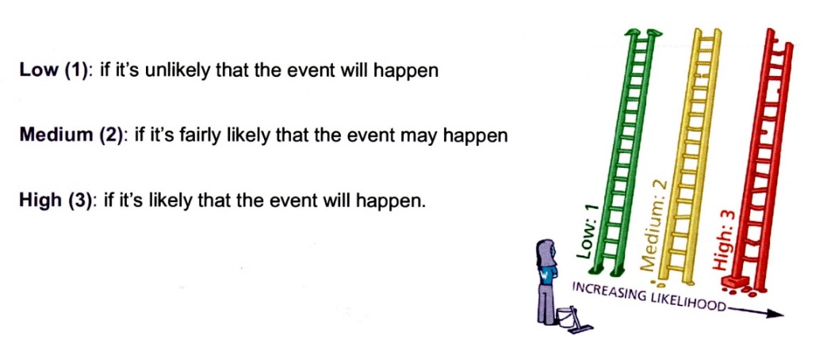
Step Two: think about the consequences.

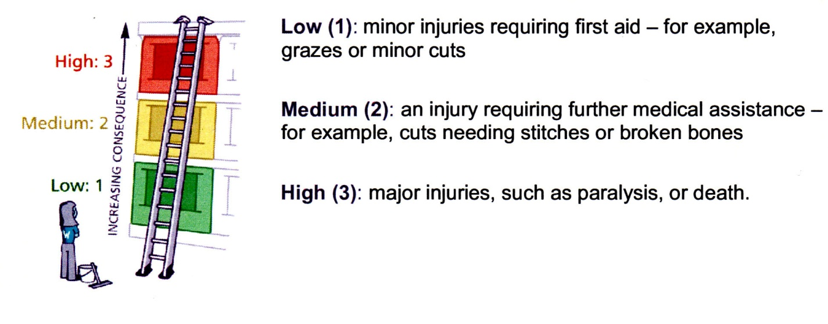

Step Three: put the likelihood together with the consequences to assess whether the risk is acceptable, tolerable or unacceptable.

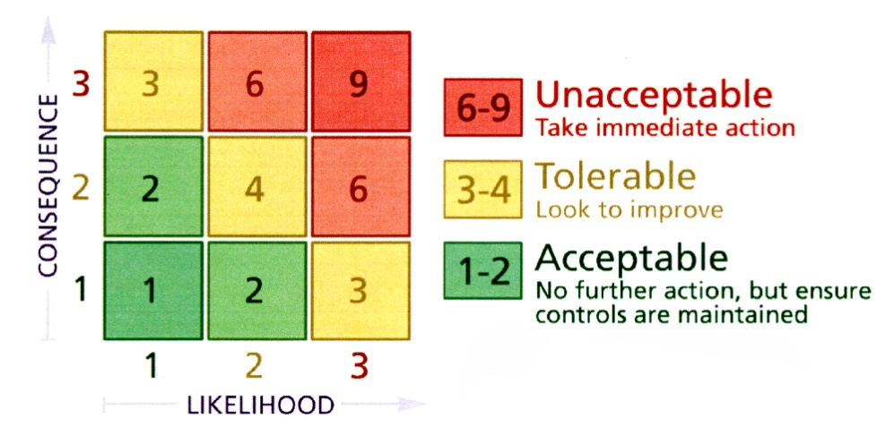

Now, ask yourself whether you can reduce the risk by introducing risk control measures. Take advice from Diana Johnson or a PCC member if you are unsure.

Employees informed of risk assessment via all of the following means: | 1. Event organiser completing Risk Assessment, with advice from Health & Safety Coordinator  2. Church Warden or event organiser to check through Risk Assessment and any supporting documents. All relevant Committee members will be issued with a copy of these documents by the event organiser.  3. Urgent announcement (if deemed necessary) to the public and/or volunteers should there be any further risk identified in the lead up to the event or at the venue.  5. Volunteers on duty to be briefed by the activity organiser on activity arrangements and on Risk Assessment.  6. All H&S incidents to be logged in Church Accident Book held in the Church Cottage
Volunteers to report newly-identified hazards via: | The event organiser, Church Warden or a PCC member

Any safeguarding incident / concern must be reported immediately to the Parish Safeguarding Officer David Mackenzie

RISK ASSESSMENT COMPLETED BY Event Organiser
Date: |  | Event Organiser to sign:
RISK ASSESSMENT APPROVED BY Church Warden or Priest in Charge
Date: | 30th October 2021 | Church Warden or Priest in Charge to sign: | 