Parish Church of St James, Riding Mill
Risk Assessment
Tea and Tots Group in the Church Cottage
Author and Health & Safety Coordinator:
Rev’d Diana Johnson

Risk area: | Parish Church of St James, Riding Mill  Tea and Tots Group in the Church Cottage  Risk Assessment

Assessment  performed by: | Diana Johnson
Activities by: | Tea and Tots Group – Tea and Tots @ St James’ Cottage
Authority: | Parish Church of St James, Riding Mill Parochial Church Council. Parish telephone 01434 682 768. http://www.stjameschurchridingmill.com/

Potential Hazards  in this Risk Area | Estimated Risk Level (BEFORE control measures considered) |  |  | Control measures  that could be used to reduce the risk | Final Risk Level  (after control measures introduced)
 | Unacceptable | Tolerable | Acceptable |  | Unacceptable | Tolerable | Acceptable
Emergency evacuation of Church Cottage. |  | ✓ |  | For those unfamiliar with Church Cottage it may be necessary to explain that emergency evacuation is by the main door through which they entered. In the lobby area there is a copy of a guidance document on how to summon help in different emergency situations.  THE FIRE ASSEMBLY POINT IS ON THE CORNER OF THE CAR PARK, BESIDE THE SPINNEY. |  |  | ✓
Dealing with abusive members of the public or colleagues whilst involved in church duties. |  | ✓ |  | In the first instance raise your concern(s) immediately with the priest in charge, organiser or churchwarden team. Exceptionally, the Parish Safeguarding Officer will manage your concern. |  | ✓
Accidents, including major accident , falls and collisions, and illness |  | ✓ |  | First-aid equipment is to be readily accessible  Any slip hazards such as spilt water must be cleared immediately.  Any damage or defects in floor coverings must be reported to the churchwarden team who will assess and correct as necessary.  Trailing electrical cables and other trip hazards must be removed immediately.  Obstacles to normal movement in and around church cottage must be removed immediately and must never be allowed to obstruct the emergency evacuation route.  All church officers and volunteers must be constantly mindful of the special needs of children, the elderly and the infirm and offer advice/ help on negotiating the entrance into the cottage. Also special attention needs to be paid to children, the elderly and infirm once they leave the cottage and reach Church Lane because of the hazard from traffic..  In the event of a major emergency ambulance should be called immediately. An adult volunteer to go to the Old Playground car park to guide ambulance crew. Ensure good access to telephones, which includes volunteers mobiles as well. |  |  | ✓
Security of children compromised, if children are present. Children have a lesser awareness of risk and so require special thought to be given to mitigate any risk. | ✓ |  |  | Security of children compromised, if children are present. Children have a lesser awareness of risk and so require special thought to be given to mitigate any risk.  Note especially:  Safeguarding  This parish recognises that the welfare of children, young people and vulnerable adults is paramount and that we have a duty of care when they are in our charge. Furthermore this is the responsibility of all church members.  We will do everything that we can to provide a safe and caring environment whilst they attend our activities.  We will:  - Treat all children, young people and vulnerable adults with respect and celebrate their achievements  - Recruit and select all those working with children, young people and vulnerable adults on our behalf in accordance with Diocesan Safer Recruitment procedures  - Provide a code of conduct for all staff to include the assessment of risk for key roles when working with children, young people and vulnerable adults  - Respond to concerns and allegations without delay in accordance with Diocesan Safeguarding procedure  The PCC has adopted the Church of England’s policies and best practice on safeguarding which may be found on the Church of England’s website and the Diocese of Newcastle’s website.  For more information about Riding Mill’s Church Safeguarding policy please click here. |  | ✓
Risk from electrical equipment, incorrect use of equipment and use of defective equipment |  | ✓ |  | Any electrical equipment, such as music players, visually checked for safety and loose cables taped down or covered by heavy matting.  Report any electrical defect immediately to the Churchwardens and take it out of use. Clearly label any defective equipment to prevent further use. Defective includes frayed cables, cracked or chipped plugs etc  Only a competent person may undertake any work on electrical equipment, including changing fuses and plugs. |  |  | ✓
Activities involving working at a height e.g. access to high cupboards in the cottage or the loft. |  | ✓ |  | ONLY AUTHORISED CHURCH OFFICERS ARE PERMITTED TO USE THE LOFT LADDER AND LOFT.  Those visitors to cottage helping with meeting set up or tidying up must take special care when storing items on the shelving and when accessing and storing chairs and tables. When storing items on shelving only small, light and easily lifted items can be placed on higher shelves and heavier items must be placed as low as possible. Special care is needed with chairs to avoid them toppling forward and also with tables. For this reason, only authorised volunteers or organisers are permitted to set up tables and chairs in the cottage. |  |  | ✓
Manual handling injuries from lifting heavy items |  | ✓ |  | Obtain help from a colleague. For some items it may be possible to divide them into manageable loads. |  |  | ✓
Risk of cuts from broken glass |  | ✓ |  | Ensure any broken glass is cleared immediately.  Always wear suitable gloves to handle broken glass. Always clear broken glass with suitable equipment (i.e. dust pan and brush etc.) Always dispose of broken glass into suitable container. |  |  | ✓
Inadequate fire equipment or low awareness leads to fire injuries | ✓ |  |  | The EVACUATION ROUTE IS THROUGH THE FRONT DOOR,  There is a FOAM FIRE EXTINGUISHER in church cottage beside the fireplace and a CO2 EXTINGUISHER and FIRE BLANKET in the kitchen.  Note that if clothing has accidentally caught alight the FIRE BLANKET can be wrapped around the individual to smother the flames.  Note that Foam Fire extinguishers must not be used on electrical fires nor on fires involving cooking oil or fat.  A LIST OF TELEPHONE NUMBERS TO SUMMON HELP IN AN EMERGENCY IS AVAILABLE IN THE LOBBY AREA OF THE COTTAGE & SEPARATE INSTRUCTIONS ON USE OF THE FIRE EXTINGUISHER AND FIRE BLANKET ARE DISPLAYED IN THE KITCHEN AND BESIDE THE EXTINGUISHER. |  | ✓

Risks associated with Tea and Tots Group activities
Some Potential Hazards  in this Risk Area | Estimated Risk Level (BEFORE control measures considered) |  |  | Control measures  that could be used to reduce the risk | Final Risk Level  (after control measures introduced)
 | Unacceptable | Tolerable | Acceptable |  | Unacceptable | Tolerable | Acceptable
Slip hazard |  | ✓ |  | Use of warning bollard when slip hazard identified and immediate correction by organiser and parents/carers |  |  | ✓
Trip hazard |  | ✓ |  | If trip hazard due to temporary location of toys, baby carriers etc then immediate correction by organiser and parents/carers.  If trip hazard due to fixtures within the cottage then organiser corrects or reports to priest in charge or church warden team the nature of the hazard so that a permanent solution is found. |  |  | ✓
Scalding from hot drinks | ✓ |  |  | No hot drinks to be consumed in ways that children could be scalded.  Hot drinks to be consumed away from immediate area where children are present/ playing and except in kitchen area drinks must be transported and consumed in re-usable spill proof containers/ mugs. |  | ✓
Kitchen hazards | ✓ |  |  | Children must not be allowed in the kitchen area where hazards including kettles, trailing wires, boiling water, kitchen knives etc are present. |  |  | ✓
Storage of toys |  | ✓ |  | Organisers Kate Houseman and Christine Kimpton have been given permission to use ladder access for retrieval and storage of toys in the cottage loft if necessary. This will be done at such times when other parents/carers and children are not in harms’ way.  Parents/carers must not use ladder access to retrieve/ store toys in the cottage loft.  Toys must be stored in the cupboard, on shelves, and extreme care must be taken when lifting and storing toys from shelves and children must not be nearby.  Larger toys must be stored on lower shelves and only small, light and easily lifted toys on higher shelves. When lifting toys from higher shelves the portable steps provided must be used.  (see also ‘working at height in main risk assessment above)  Special care must be taken to ensure that parents/carers and children do not dislodge tables and chairs stored in the cupboards. |  |  | ✓
Obtaining engagement and commitment from parents relating to identified risks and obtaining contact details for parents and others in case of an emergency. | ✓ |  |  | PARENTS/CARERS ATTENDING THE GROUP ARE REQUIRED TO FILL OUT AND SIGN A REGISTRATION FORM AT OR BEFORE FIRST ATTENDANCE. The form will require the parents/carers to commit to reading, understanding and abiding by the recommended actions in this risk assessment and for providing contact details, for family members, to be used in an emergency. |  | ✓
Notification of infectious diseases |  |  | ✓ | Parents/carers will be given contact details for the group organisers and asked to inform the organisers of any risks to other parents/carers and toddlers that may arise after attending the group (e.g. infectious illness). The organisers will use the contact details head to inform other attendees of such events. |  |  | ✓
COVID-19 | ✓ |  |  | Parents/carers and children attending the group will be asked to sanitize hands on entry.  According to current government guidelines (as of 1/1/2022); masks do not need to be worn in parent-baby groups and where groups involve eating and drinking. However, signs will indicate that parents can wear masks should they wish to. Parents will also be encouraged to perform lateral flow tests before coming, although this is not a requirement.  The Church will supply an air quality monitor (CO2 monitor) as a proxy for ventilation - if the reading creeps above 800ppm, it indicates extra ventilation is required and doors should be opened. ide extra ventilation. Such monitor use is recommended and described in Health and Safety Executive guidance. A baby gate will be installed on the internal door such that children can’t run out of the building whilst doors are open. |  |  | ✓
If one of these hazards is identified in an event, please tick ( ✓) the level of risk, and indicate the date when any consequent controls were put in place. For additional hazards and/or control measures, please use the table below.

Parish Church of St James, Riding Mill Handy Guide for Assessing Risk

Remember, risk is a mix of two factors: likelihood and consequence. This is how to assess them at St James’s Parish Church:
Step One: think about the likelihood.

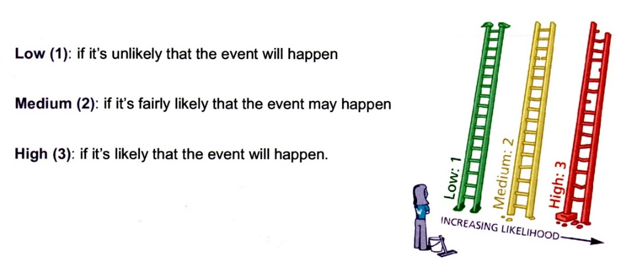
Step Two: think about the consequences.

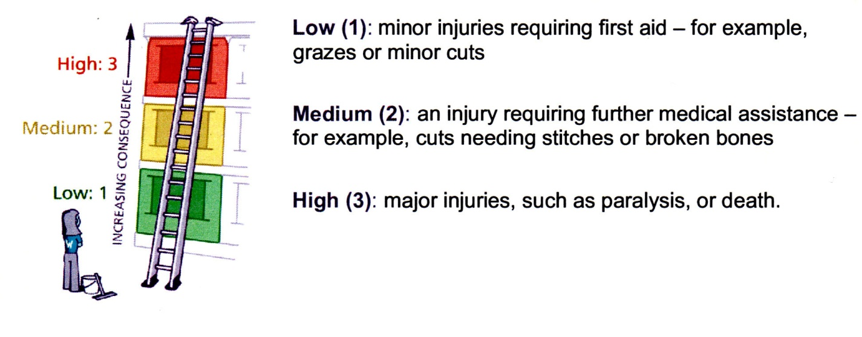

Step Three: put the likelihood together with the consequences to assess whether the risk is acceptable, tolerable or unacceptable.

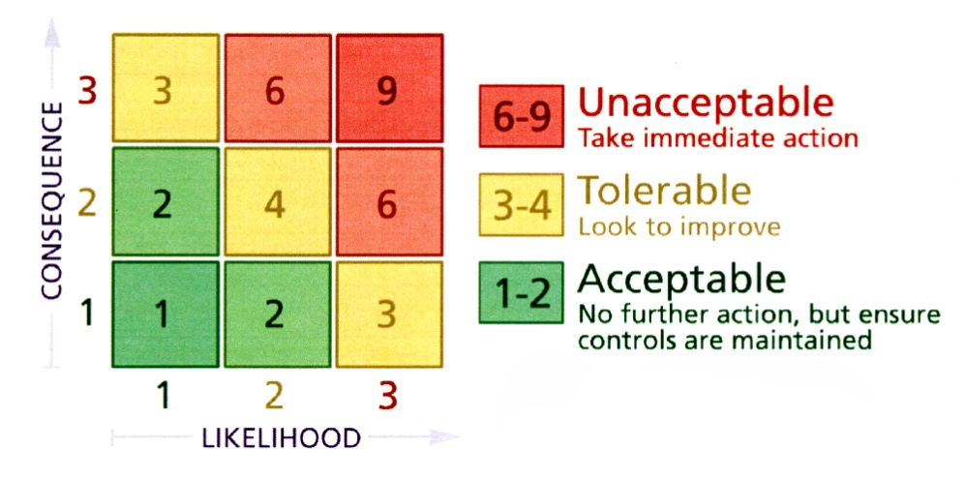

Now, ask yourself whether you can reduce the risk by introducing risk control measures. Take advice from Diana Johnson or a PCC member if you are unsure.

TEA AND TOTS @ ST JAMES’ COTTAGE, RIDING MILL

REGISTRATION FORM AND GDPR

(One copy to be retained by the organiser and one by the parent/carer)

CHILD’S NAME
AND AGE

PARENT/CARER’S
- NAME
- TELEPHONE NUMBER

CONTACT NAME & NUMBER TO BE USED IN AN EMERGENCY

BY SIGNING THIS REGISTRATION FORM, I THE ABOVE NAMED:
- AGREE TO THE ABOVE CONTACT DETAILS BEING KEPT SECURELY BY THE GROUP ORGANISERS AND UNDERSTAND THAT THE DETAILS WILL BE CONFIDENTIALLY DESTROYED WHEN I OR MY CHILD CEASE TO ATTEND THE GROUP
AND
- CONFIRM THAT I HAVE READ, UNDERSTOOD, AGREE TO ABIDE BY AND COMMIT TO ASSISTING WITH HEALTH AND SAFETY AS OUTLINED IN THE ATTACHED RISK ASSESSMENT.

SIGNED DATE

ORGANISERS Kate Houseman / Christine Kimpton
CONTACT NUMBER 07940519720 / 07780555598

TEA AND TOTS @ ST JAMES’ CHURCH COTTAGE, RIDING MILL
SIGNING IN SHEET

DATE
ORGANISERS NAME AND CONTACT DETAILS

CHILD’S NAME | PARENT/CARER’S NAME | SIGNED REGISTRATION & GDPR FORM*
* PLEASE TICK TO CONFIRM YOU HAVE SIGNED A REGISTRATION AND GDPR FORM (EITHER TODAY OR PREVIOUSLY)

Employees informed of risk assessment via all of the following means: | 1. Event organiser completing Risk Assessment, with advice from Health & Safety Coordinator  2. Church Warden or event organiser to check through Risk Assessment and any supporting documents. All relevant Committee members will be issued with a copy of these documents by the event organiser.  3. Urgent announcement (if deemed necessary) to the public and/or volunteers should there be any further risk identified in the lead up to the event or at the venue.  5. Volunteers on duty to be briefed by the activity organiser on activity arrangements and on Risk Assessment.  6. All H&S incidents to be logged in Church Accident Book held in the Church Cottage
Volunteers to report newly-identified hazards via: | The event organiser, Church Warden or a PCC member

Any safeguarding incident / concern must be reported immediately to the Parish Safeguarding Officer David Mackenzie

RISK ASSESSMENT COMPLETED BY Event Organiser
Date: | 29/10/2021 | Event Organiser to sign: | Kate Houseman
RISK ASSESSMENT APPROVED BY Church Warden or Priest in Charge
Date: | 30th October 2021 | Church Warden or Priest in Charge to sign: | 