Parish Church of St James, Riding Mill
Risk Assessment
Advent and Christmas Services 2021
Author and Health & Safety Coordinator:
Rev’d Diana Johnson

Risk area: | Parish Church of St James, Riding Mill  Advent and Christmas Services 2021  Risk Assessment

Assessment  performed by: | Diana Johnson
Activities by: | Parochial Church Council
Authority: | Parish Church of St James, Riding Mill Parochial Church Council. Parish telephone 01434 682 768. http://www.stjameschurchridingmill.com/

Potential Hazards  in this Risk Area | Estimated Risk Level (BEFORE control measures considered) |  |  | Control measures  that could be used to reduce the risk | Final Risk Level  (after control measures introduced)
 | Unacceptable | Tolerable | Acceptable |  | Unacceptable | Tolerable | Acceptable
Consumption of alcohol (authorised or not) can reduce awareness of hazards, leading to degraded decision making and risky behaviour |  | ✓ |  | Consumption of alcohol limited to specific time and place.  Used wine glasses should be kept cleared up. If placed on the floor and knocked over we could have broken glass (see extra advice below). |  |  | ✓
Violence or aggression towards volunteers |  | ✓ |  | Volunteers work all in one place or where they can monitor one another’s well-being. People not to be alone with children or adults such as parents |  |  | ✓
Accidents, including major accident , falls and collisions, and illness | ✓ |  |  | First-aid equipment is to be readily accessible (Churchwardens to check please)  Behaviour monitored throughout so that no one is hurt through e.g. too boisterous behaviour. All volunteers knowing who to consult/check with/report to if there is an incident or someone becomes ill or there is an accident (Churchwardens or clergy)  First aid kit at hand. Whereabouts to be known to everyone.  In the event of a major emergency ambulance should be called immediately. An adult volunteer to go to entrance of Church or Old Playground car park to guide ambulance crew. Ensure good access to telephones, which includes volunteers mobiles as well. |  |  | ✓
Safeguarding Visitors and Volunteers – people put at risk | ✓ |  |  | Children come with parents/ carers who are responsible for their care.  Reminder to parents/carers of their duty of care.  Volunteers are not to be left in sole charge of a child or vulnerable adult at any time during the event.  Named volunteers have DBS checks, e.g. clergy, ministry team, churchwardens.  Any safeguarding incident to be reported to Parish Safeguarding Officer, David Mackenzie immediately.  Note especially:  Safeguarding  This parish recognises that the welfare of children, young people and vulnerable adults is paramount and that we have a duty of care when they are in our charge. Furthermore this is the responsibility of all church members.  We will do everything that we can to provide a safe and caring environment whilst they attend our activities.  We will:  - Treat all children, young people and vulnerable adults with respect and celebrate their achievements  - Recruit and select all those working with children, young people and vulnerable adults on our behalf in accordance with Diocesan Safer Recruitment procedures  - Provide a code of conduct for all staff to include the assessment of risk for key roles when working with children, young people and vulnerable adults  - Respond to concerns and allegations without delay in accordance with Diocesan Safeguarding procedure  The PCC has adopted the Church of England’s policies and best practice on safeguarding which may be found on the Church of England’s website and the Diocese of Newcastle’s website.  For more information about Riding Mill’s Church Safeguarding policy please click here. |  | ✓
Wheel-chair users - access and exit from church |  | ✓ |  | Ensure that there are routes available for wheelchair users to enter and exit the premises unimpeded. Ensure that the ramp is available to assist access at the pavement step and use baptistry/ nave access rather than through transept door.  Action: Organiser and churchwardens. |  |  | ✓
Trips and falls – steps, floor, cables |  | ✓ |  | Ensure that children and those with special needs are helped to negotiate steps and other obstacles within church by family members and friends or by church officers if requested. The location of alternative routes should be advised at the outset of the service of event.  Ensure the floor is kept clear of spills and no cables or other materials are located in a way that they could cause a trip hazard  Power for amplification taken from electrical sockets where they will not involve trailing cables and a trip hazard.  Entry to the event via nave door (notice on transept door) to avoid chancel step and steps at transept door.  Action: Organiser and churchwardens. |  |  | ✓
Difficulty of egress from church e.g. blocked routes |  | ✓ |  | In preparation for and immediately before the start of the service or event all designated emergency exits must be checked to ensure they are unlocked and no route is blocked. Importantly seats or other obstacles must not obscure free movement through Transept and/or Nave/ Baptistry.  Action: Organiser and churchwardens. |  |  | ✓
Difficulty in evacuating large numbers in case on an emergency |  | ✓ |  | The organiser must appoint suitable persons to assist visitors with evacuation of church in the event of an emergency. Ensure all fire exits are unlocked, clear and unobscured at all times. Also ensure at the start of the event that the organiser announces the location of all emergency exits. In the case of large events the ushers should be involved and the designated escape routes from church explained to them. THE FIRE ASSEMBLY POINT IS ON THE CORNER OF THE CAR PARK, BESIDE THE SPINNEY.  Action: Organiser and churchwardens. |  |  | ✓
Electrical equipment used for concerts and other events. |  | ✓ |  | Ensure all electrical equipment is PAT tested prior to use – ensure that performers understand that they are responsible for the safe use of their own equipment.  Action: Organiser and churchwardens. |  |  | ✓
Hazards from traffic after leaving church and church gates. | ✓ |  |  | For any event with large numbers attending special care must be taken when leaving on Church Lane. The priest in charge or organiser must warn those attending of the danger at the outset of the service/ event. For weddings ushers will be asked to supervise traffic and for funeral/ burials normally the churchwarden team will appoint helpers to control traffic when the coffin is leaving church. For other events the school or organiser must warn those attending the event that children and elderly infirm visitors must be closely supervised when exiting church and entering Church Lane because of the hazard from moving traffic.  Action: Organiser and churchwardens. |  |  | ✓

NOTE: A separate RISK ASSESSMENT – CHURCH PREMISES must be read in conjunction with this document. Depending on what is planned it may be necessary to prepare a specific RISK ASSESSMENT for the SPECIAL SERVICE / EVENT as different specific risks may be identified.

NOTE: A LIST OF CONTACT NUMBERS TO SUMMON HELP IN AN EMERGENCY IS DISPLAYED IN THE NAVE & TRANSEPT LOBBIES.
Risks associated with Covid
Some Potential Hazards  in this Risk Area | Estimated Risk Level (BEFORE control measures considered) |  |  | Control measures  that could be used to reduce the risk | Final Risk Level  (after control measures introduced)
 | Unacceptable | Tolerable | Acceptable |  | Unacceptable | Tolerable | Acceptable
Airborne transmission | ü |  |  | Masks strongly recommended including when seated.  Sidespeople to wear PPE (esp. masks) when stewarding.  Post-service socialising requested to be outside.  Singing is permitted.  Ventilation: The outside doors of the church will be left open slightly and the inner doors open all the time to keep some movement of air. The heating will be on |  | ü
Touch and contact transmission | ü |  |  | Hand sanitiser and masks supplied and encouraged by sidespeople.  Communion will continue to be in one kind and cross-contamination minimised. |  | ü
General social distancing required |  | ü |  | Social distancing regulated by limiting attendance. “It has been decided that we limit the number for this to 75 and that we strongly recommend people to wear masks”  Ticketing may be required to meet that need for special services.  In the case of most services, experience shows that numbers are always below this limit and so ticketing is not currently required. |  |  | ü
If one of these hazards is identified in an event, please tick ( ü) the level of risk, and indicate the date when any consequent controls were put in place. For additional hazards and/or control measures, please use the table below.

Risks associated with catering (refreshment is drinks only in 2021)
Some Potential Hazards  in this Risk Area | Estimated Risk Level (BEFORE control measures considered) |  |  | Control measures  that could be used to reduce the risk | Final Risk Level  (after control measures introduced)
 | Unacceptable | Tolerable | Acceptable |  | Unacceptable | Tolerable | Acceptable
Lack of personal hygiene on part of volunteers | ✓ |  |  | Hand washing before and after. Wear gloves when handling cups and wine. |  | ✓
Visitors and Volunteers  Hazards: allergic reaction to refreshments; | ✓ |  |  | Clear labelling of ingredients used in refreshments (including mulled wine); Provide suitable labels of ingredients. |  | ✓
State of electricity, gas and water supplies, if present, is unsafe | ✓ |  |  | Activity organiser to conduct visual check |  |  | ✓
Spillages may cause burns or other hazards: Hot drinks/carrying trays |  | ✓ |  | Action in case of spillage is to wipe up immediately  Risks mitigated by removing trip hazards in refreshment area, paying particular attention to area near to kettles/urns. Hot drinks served by designated volunteers and handed to the recipient.  Check refreshment area before event.  Only volunteers who can carry a tray safely will be asked to do so. |  | ✓
Storage arrangements not hygienic | ✓ |  |  | Tables wiped down by antiseptic cleaner or paper coverings used. |  | ✓
Insufficient lighting around serving and preparation areas. |  | ✓ |  | Activity organiser to ensure all lights are on when in use. |  |  | ✓
If one of these hazards is identified in an event, please tick ( ✓) the level of risk, and indicate the date when any consequent controls were put in place. For additional hazards and/or control measures, please use the table below.

Parish Church of St James, Riding Mill Handy Guide for Assessing Risk

Remember, risk is a mix of two factors: likelihood and consequence. This is how to assess them at St James’s Parish Church:
Step One: think about the likelihood.

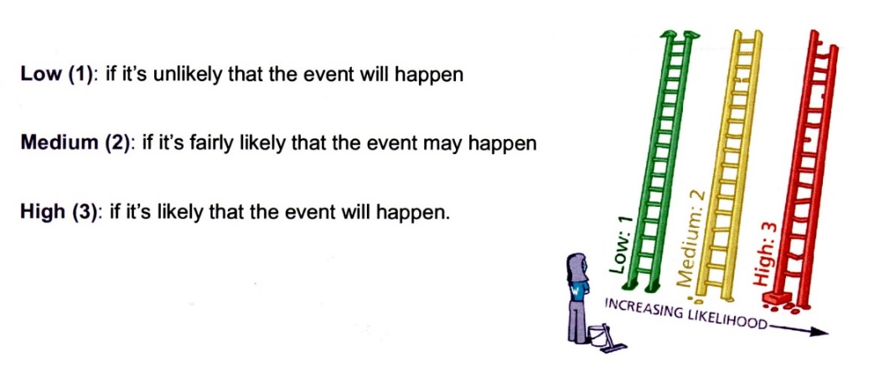
Step Two: think about the consequences.

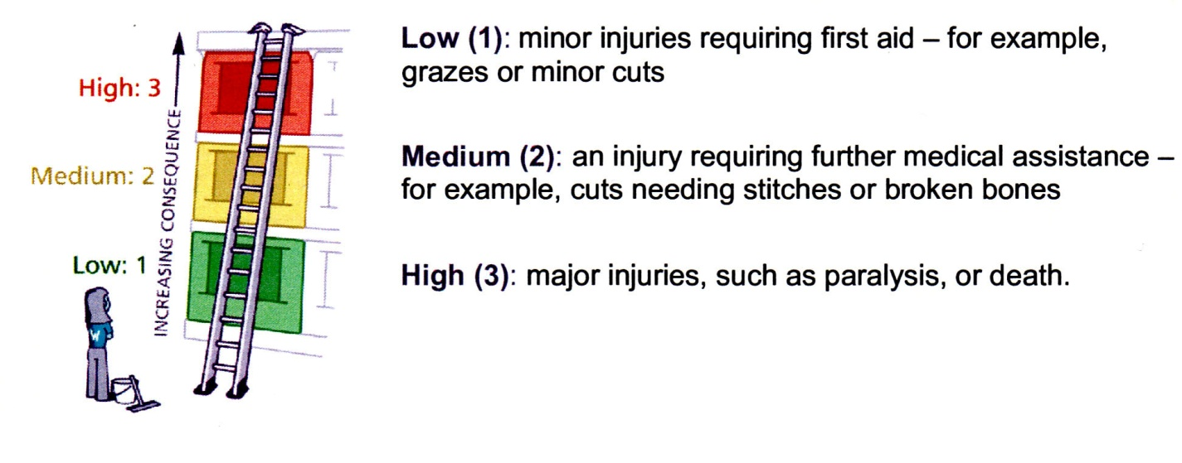

Step Three: put the likelihood together with the consequences to assess whether the risk is acceptable, tolerable or unacceptable.

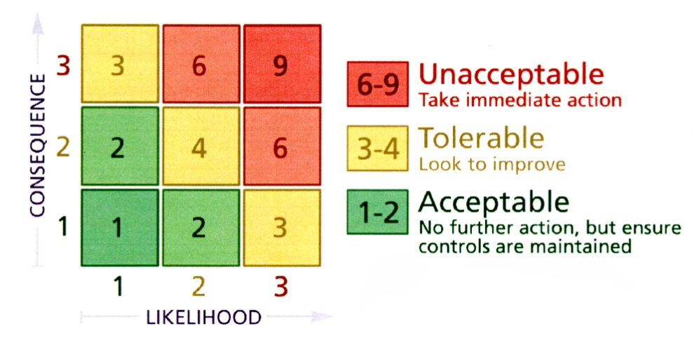

Now, ask yourself whether you can reduce the risk by introducing risk control measures. Take advice from Diana Johnson or a PCC member if you are unsure.

Employees informed of risk assessment via all of the following means: | 1. Event organiser completing Risk Assessment, with advice from Health & Safety Coordinator  2. Church Warden or event organiser to check through Risk Assessment and any supporting documents. All relevant Committee members will be issued with a copy of these documents by the event organiser.  3. Urgent announcement (if deemed necessary) to the public and/or volunteers should there be any further risk identified in the lead up to the event or at the venue.  5. Volunteers on duty to be briefed by the activity organiser on activity arrangements and on Risk Assessment.  6. All H&S incidents to be logged in Church Accident Book held in the Vestry
Volunteers to report newly-identified hazards via: | The event organiser, Church Warden or a PCC member

Any safeguarding incident / concern must be reported immediately to the Parish Safeguarding Officer David Mackenzie

RISK ASSESSMENT COMPLETED BY Event Organiser
Date: |  | Event Organiser to sign: | Email 19th November 2021
RISK ASSESSMENT APPROVED BY Church Warden or Priest in Charge
Date: | 17 Nov 21 and revised 21st November 2021 | Church Warden or Priest in Charge to sign: | 