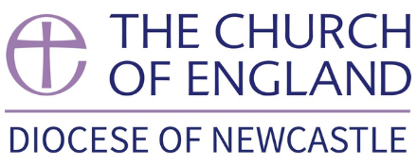

DIOCESE OF NEWCASTLE
Ministerial Development Review

Commentator Form (Member of Church or Ministry Setting)

Name of person being reviewed

Date arranged for the Review meeting

It would be very helpful if this form could be

completed and returned by to

Email address

Postal Address

Commentator’s Name

……………………………………………………………………………………………………………….

Relationship with Reviewee/role in the community

………………………………………………………..…..

Your contact email address & tel. no.

………………………………………………………………………………………..

Your postal address

……………………………………………………………………………………………………………………………………………

……………………………………………………………………………………………………………………………………………

Please try to answer as many of the questions as you can and write as freely as you need to.

1. What, in your experience, does this person do ‘well’ in ministry? Can you give an example of something that you saw bring them joy or excitement?

2. Can you think of any examples that suggest that they would appreciate or benefit from further help/support/training?

3. Can you give examples of this person working successfully with others? What signs are there that others are flourishing because of this person’s ministry?

5. Can you think of anything that may be having an impact on this person’s ministry?

6. What gifts and qualities does this person have of which you think the Bishop should be aware?

7. In so far as you know, is this person taking sufficient time off?

8. Is there anything else you would like to add?

(We encourage you to share what you have written with the reviewee. You might like to hand over a copy of it directly.)

Signed: THANK YOU

