Parish Church of St James, Riding Mill
Risk Assessment
Ascension Rocket
Author and Health & Safety Coordinator:
Rev’d Diana Johnson

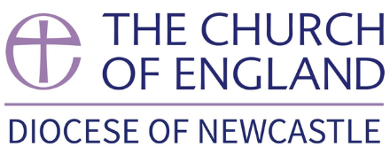

Risk area: | Parish Church of St James, Riding Mill  Ascension Rocket Risk Assessment

Assessment  performed by: | Diana Johnson
Activities by: | Parochial Church Council or other small group
Authority: | Parish Church of St James, Riding Mill Parochial Church Council. Parish telephone 01434 682 768. http://www.stjameschurchridingmill.com/

Potential Hazards  in this Risk Area | Estimated Risk Level (BEFORE control measures considered) |  |  | Control measures  that could be used to reduce the risk | Final Risk Level  (after control measures introduced)
 | Unacceptable | Tolerable | Acceptable |  | Unacceptable | Tolerable | Acceptable
Injury caused by fireworks  Inadequate space  Spectators use fireworks  Unauthorised use of display fireworks | ✓ |  |  | - 50m x 25m space has been allowed for the firing area.  - A dropping zone for spent fireworks of 100m x 50m is in place in a downwind direction (check weather conditions)  - Spectators are to be kept back on the opposite side from the dropping zone at least 25m from the firing zone.  - The area has been checked and is free from obstructions i.e. trees, overhead power cables and well away from buildings.  - Suitable secure area for firework storage inaccessible to public.  - Firing area supervised once fireworks set up.  - Spectators will not be allowed to enter the site with their own fireworks, including sparklers.  - Spent firework cases gathered, site also checked at first light for partly spent fireworks. |  | ✓
Fire  Ignition of premises |  | ✓ |  | - Adequate separation from buildings (see above)  - Adequate water, sand buckets etc.  - Positioned in appropriate places to allow quick access |  |  | ✓
Insufficient and/or unsuitable first aid cover |  | ✓ |  | - First aid equipment on site and close to use.  - Designated qualified first aiders available.  - Telephones available / mobile phones available |  | ✓

Parish Church of St James, Riding Mill Handy Guide for Assessing Risk

Remember, risk is a mix of two factors: likelihood and consequence. This is how to assess them at St James’s Parish Church:
Step One: think about the likelihood.

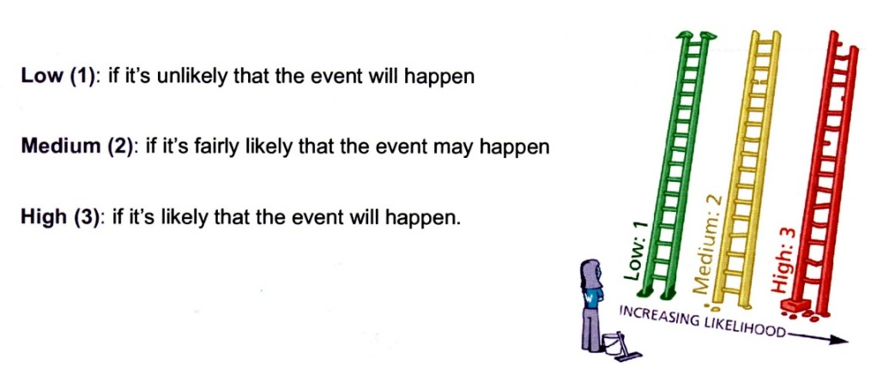
Step Two: think about the consequences.

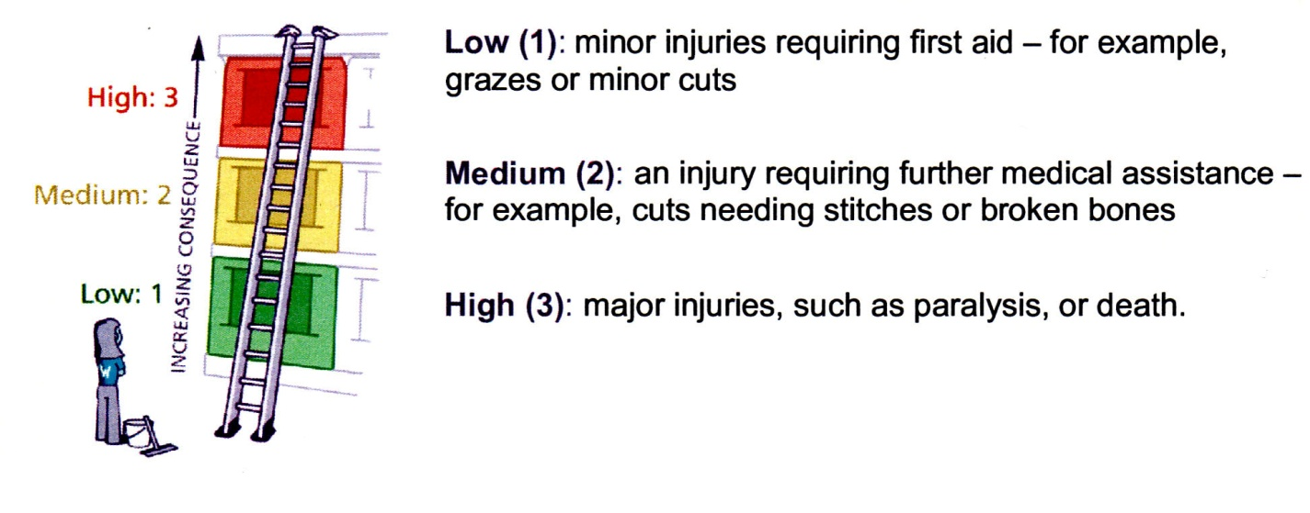

Step Three: put the likelihood together with the consequences to assess whether the risk is acceptable, tolerable or unacceptable.

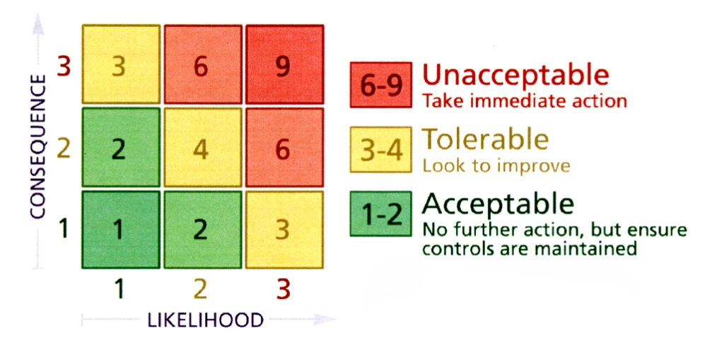

Now, ask yourself whether you can reduce the risk by introducing risk control measures. Take advice from Diana Johnson or a PCC member if you are unsure.

Employees informed of risk assessment via all of the following means: | 1. Event organiser completing Risk Assessment, with advice from Health & Safety Coordinator  2. Church Warden or event organiser to check through Risk Assessment and any supporting documents. All relevant Committee members will be issued with a copy of these documents by the event organiser.  3. Urgent announcement (if deemed necessary) to the public and/or volunteers should there be any further risk identified in the lead up to the event or at the venue.  5. Volunteers on duty to be briefed by the activity organiser on activity arrangements and on Risk Assessment.  6. All H&S incidents to be logged in Church Accident Book held in the Vestry
Volunteers to report newly-identified hazards via: | The event organiser, Church Warden or a PCC member

Any safeguarding incident / concern must be reported immediately to the Parish Safeguarding Officer David Mackenzie

RISK ASSESSMENT COMPLETED BY Event Organiser
Date: | 17th May 2022 | Event Organiser to sign: | 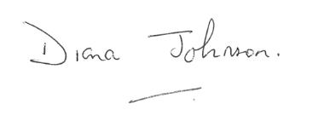
RISK ASSESSMENT APPROVED BY Church Warden or Priest in Charge
Date: |  | Church Warden or Priest in Charge to sign:

