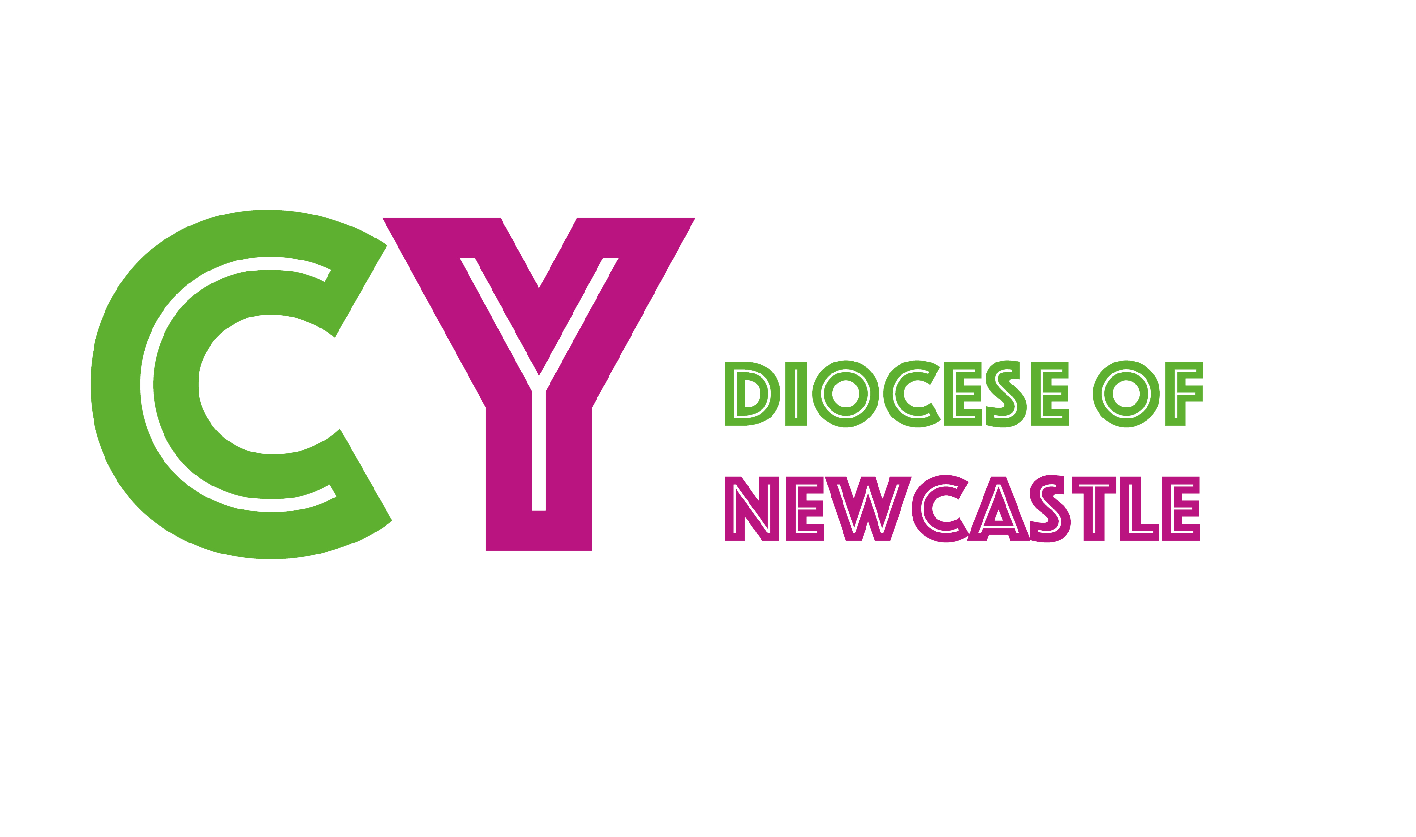
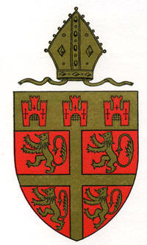

Diocese of Newcastle
Admission of Baptised Children to
Holy Communion before Confirmation

Introduction
We would encourage parishes to offer admission of baptised children to Holy Communion before Confirmation. There are many exciting ways to do this, so please feel free to email us to discuss how it could work for you.
Since September 2000 it has been possible for parishes to apply to the Bishop of Newcastle, seeking their agreement for the admission of baptised persons to Holy Communion before Confirmation.
This document has been produced to assist parishes through the process.
The Bishop of Newcastle abides by the Regulations agreed by General Synod in 2006. These can be found at
https://www.churchofengland.org/sites/default/files/2018-10/gs1596-admission-of-baptized-children-to-holy-communion.pdf
The Process
- Reflection, discussion and learning within the parish.
- PCC must pass a resolution with a two third majority to adopt a policy in favour of Admission to Holy Communion before Confirmation – a draft policy is available. If the parish is part of a Local Ecumenical Project “the other participating Churches” must be consulted.
- Application Form must be completed and sent to Revd Rachel Scheffer with a copy of the signed and adopted PCC resolution to be approved by the Bishop of Newcastle.
- Parental consent in writing must be obtained – form available.
- Candidates must be prepared for Admission to Holy Communion.
- The first Holy Communion service – baptism certificate should be updated with date and place of first communion. If the baptism certificate isn’t available there is a certificate available which can be completed and given at the time of first receiving communion.
- A register must be kept of those who are admitted to Holy Communion before Confirmation – this should include name, address, date and place of baptism and date and place of admission to Holy Communion.
- Candidates encouraged to continue with Christian nurture and to seek Confirmation at an appropriate time
All forms and documents are available from Tara Russell, Children and Youth Team Leader – contact details are at the end of this document.
We would like to encourage parishes to visit our website www.newcastle.anglican.org/youth where you will be able to download Application Form, a suggested Parish Policy, Parental Consent Form and Certificate of Admission to Holy Communion.
We also recommend the book Ready To Share One Bread by Nick Harding and Sandra Millar ISBN 978 0 281 07053 4 (This is available at North East Religious Resources Centre - www.resourcescentreonline.co.uk ). It will be important to use this book in a way that suits your own church and parish. In the Introduction Sandra Millar explains the following:

“The book is arranged in five parts, which are discussed sequentially below, under ‘What’s in this book?’ But depending on how you like to learn and explore, you might prefer to follow different routes into this book.
- If you want to get to the practical resources, you will need to look at:
- Chapter 4 – how to explore children and communion in your parish;
- Chapter 6 – a two-part course for helping children and families prepare to receive communion;
Chapter 8 – an outline service for admitting children to communion;
Chapter 9 – more resources and ideas;
Chapter 12 – ideas and resources for continuing the journey of discipleship.
- If you want to read how things work out in practice then you will need:
Chapter 3 – how one parish went through the process;
Chapter 5 – how parishes tried out the all-age approach to preparing children;
Chapter 11 – taking the Eucharist beyond Sunday.
- If you want to explore the background and go further you will need:
Chapter 1 and 2 – the history and current practice of the Church of England;
Chapter 7 – what it means for Eucharistic worship to include everyone;
Chapter 10 – what difference it makes for children in their journey.
What’s in this book?
As mentioned above, the book is arranged in five parts, and taken together it offers all the material a parish needs.
Part 1: The Story so far looks at the current situation in the Church of England regarding admission of children to communion before confirmation. It’s an opportunity to look at the history and to discover how this ‘new’ approach is connected to the Church through history and culture. Chapter 1, by Bishop Michael Perham, offers a brief theology of children and the Eucharist, highlighting different theological reflections, looking at Scripture, and the journey that the Church of England has taken in recent years. In Chapter 2 Nick Harding goes further into the past, looking at past practice and thinking before bringing it up to the present day. For many church leaders and congregations, discovering the connections across time and place is a key to beginning the discussions.
Thinking about children and communion is not just an intellectual issue. When people begin to discuss the idea there is often a lot of emotional response. Opinions are expressed and questions are asked as adults and children alike try to think around something they may never have considered before. Part 2: Preparing the ground is the practical starting point for churches beginning to explore the questions. In Chapter 3 Nick Harding presents the story of a church as it considers the admission of children to communion. There are different opinions and there are different ideas – just as there will be in most churches. The chapter describes how one church used the processes to help everyone share their views and then arrive at a decision.

In Chapter 4 Nick offers material for exploring the issue with the whole congregation, with discussion questions, material for Bible Study and practical ideas for reflection. There are a range of different approaches and clear guidelines as to how to use them, so that a parish congregation has an opportunity to think deeply. Whatever decision is made, everyone will have explored the Eucharist in new ways.

In Part 3: Preparing the people you will find new material to help children prepare to receive communion before confirmation. Since the admission of children to communion before confirmation was first explored there have been many schemes and programmes, and different things work for different churches. This is short – it only takes place over two sessions, and it tries to avoid an overly ‘educational’ approach, offering lots of activities and interaction. It is also designed for adults and children to do together, whether at home or with the church family. Chapter 5 describes how people felt when they used this material, their hesitations and discoveries.

Chapter 6 is the course itself, with everything you need to run the two sessions. Once the children have spent some time thinking about communion, there comes a time when they will take communion for the first time and then be part of regular Eucharistic worship. Part 4: Joining in has lots of principles and practical ideas about making worship accessible to all ages, particularly thinking about children and the Eucharist. There are ideas for helping everyone take part in the liturgy, creative ways to approach prayer and a whole raft of practical ways children can help.

Chapter 7 explores the principles and Chapter 8 includes a complete liturgy to use on any Sunday when children are to be admitted to communion, complete with a talk as well as ideas for readings and prayers. There are lots of additional ideas in Chapter 9, which can be used at special services or on Sundays throughout the year.

Being admitted to communion is not the end of the process – it is simply a stage on the journey of faith and discipleship which is life-long. Part 5: Carrying on goes beyond Sunday worship, to start exploring the difference it makes to be part of a Eucharistic community. In Chapter 10 Steve Dixon draws on his research to explore the way taking communion affects and changes children. Finally, in Chapter 11 Nick Harding returns to some real stories about the impact the admission of children to communion makes on the wider church community.

Other resources:
Come and Join the Celebration - by John Muir and Betty Pedley
Welcome to the Lords Table - by Margaret Withers
Let the Children Come to Communion - by Stephen Lake
For more information and advice please contact Tara Russell, Children and Youth Team Leader 07467 563 309 or email t.russell@newcastle.anglican.org

